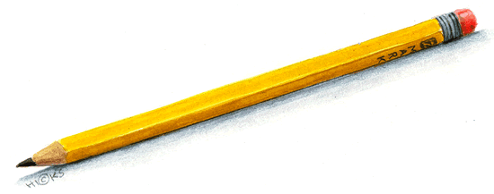**Supply Wish List**

**While most everything a first grader needs is generously supplied within  
our school district budget, there are some additional items we appreciate having.  
  
Please review the list below, and if you would like to make a donation,   
you may send the item(s) to school as needed throughout the year.  
  
Donations are optional, yet very much appreciated.  
Thank you in advance for your willingness to donate.**

**for your child:**

extra pencils (No plastic covered pencils, please. They break the sharpener. Ticonderoga are best!)

Pencil Box to keep everything together  
Pocket Folder - A special folder to keep at school for all the work we are “Still Working” on. (I can provide one for you if needed.)  
  
**for our classroom:**

extra pencils (same as above)

soft tissues    
slider style ziploc bags, all sizes

hand sanitizer          
Wet Ones Brand or Sani-Hands Brand Wipes  
Clorox Brand or Lysol Brand Cleaning Wipes

Snacks – such as goldfish, graham crackers, Nutrigrain bars, pretzels

(We will have a small snack every afternoon since we eat so early at 11:00.)

Note – If anyone has any food allergies and needs to send a specific snack, please let me know. I can also keep an area of snacks separate for them when we have birthday treats.

*The school will provide: crayons (24pk), pencils, glue sticks, writing notebooks, scissors (or you may bring your own).