  - Marketing Basics
Opening Act
Work with a partner and identify four advertising campaigns that feature celebrities or athletes. Discuss how the campaigns have affected your thinking about the product. Negative or Positive? If you were in the market for the products, would you buy the celebrity-endorsed brands? Why or why not?


4 Essential Marketing Elements (it’s not all about advertising) –

marketing –
To satisfy customers’ needs you need to perform three activities.

The Marketing Mix

marketing mix –
product –

distribution –
price –

promotion –

discretionary income –

Choosing the right product to meet the needs and wants of the market is essential to the marketing mix!

CYBER MARKETING (page 6) – Work with a partner. Visit the home pages of at least three movies that have related merchandise for sale. Determine what information is collected from customers. Discuss how the marketing information gathered could be used in the future to promote and sell other products.

How does a poor product affect the other elements of the marketing mix? ---
The Marketing Mix as it relates to purchasing a Cell Phone…
Price (How is price determined? What factors influence cost?) –

Promotion (What ways are cell phones promoted?) –

Distribution (How are cell phones distributed?) –


The Marketing Mix as it applies to the SUPER BOWL…
Price

Promotion

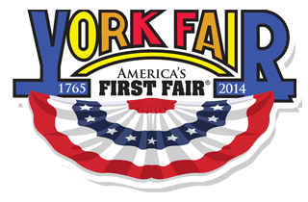
Distribution

The Marketing Mix as it applies to The York Fair…
Price

Promotion

Distribution

Six Core Standards of Marketing

Distribution –

Marketing-Information Management –

Pricing –

Product/Service Management –

Promotion –

Selling –

*Financing –

