1.2 Importance of Marketing
Write down a new and improved product that you’ve looked at or purchased recently. How is this product different from the original? Can you spot any trends within its industry?


Marketing generates .
What are some consumer benefits of marketing?
_
_
THE ONE AND ONLY EASY-TO-HOLD.
EASY-TO-OPEN. EASY-TO-POUR PAINT CONTAINER.
_
Utility: _
Five Economic Utilities (added value) involved in selling products:
Form Utility: _
Place Utility:
Time Utility:
Possession Utility:

Information Utility:

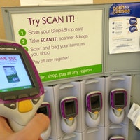
The added value to a product that marketing provides is called .
How does the market help lower prices? _
In what way is marketing related to form utility? _
Which utility is added by drive-through windows at fast food restaurants? _
MARKET TECH: “Shop ‘n’ Scan technology
How does this technology add value (utility) to a customer’s shopping experience? (page 19)
