

BUS DEPARTURE TIMES, HIGH SCHOOL GIRLS VOLLEYBALL 2019 SEASON
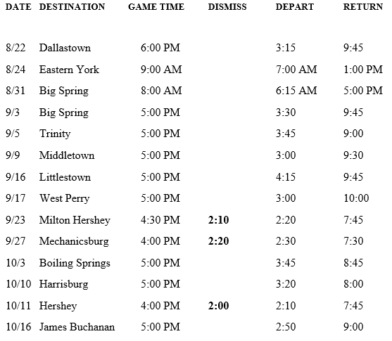

DATE DESTINATION GAME TIME DISMISS DEPART RETURN

8/22 Dallastown 6:00 PM 3:15 9:45
8/24 Eastern York 9:00 AM 7:00 AM 1:00 PM
8/31 Big Spring 8:00 AM 6:15 AM 5:00 PM
9/3 Big Spring 5:00 PM 3:30 9:45
9/5 Trinity 5:00 PM 3:45 9:00
9/9 Middletown 5:00 PM 3:00 9:30
9/16 Littlestown 5:00 PM 4:15 9:45
9/17 West Perry 5:00 PM 3:00 10:00
9/23 Milton Hershey 4:30 PM 2:10 2:20 7:45
9/27 Mechanicsburg 4:00 PM 2:20 2:30 7:30
10/3 Boiling Springs 5:00 PM 3:45 8:45
10/10 Harrisburg 5:00 PM 3:20 8:00
10/11 Hershey 4:00 PM 2:00 2:10 7:45
10/16 James Buchanan 5:00 PM 2:50 9:00

