Board Game Project (70 points)

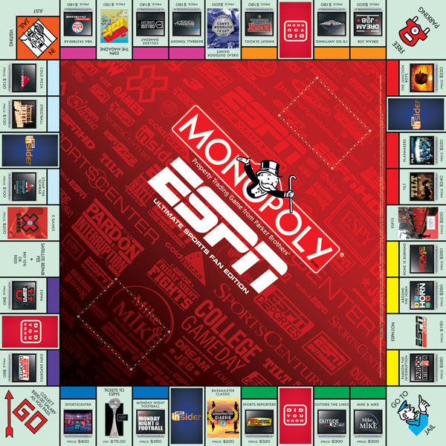
In this project you will identify the “4 P’s” of marketing and create a board game. Incorporate elements of board games and video games you already enjoy and combine them with other ideas and features you would like to see in a game.

PART 1 - Create a working “prototype” for your board game. (30 points total)
“Prototype” means a model of the game to show to a prospective board game manufacturer. Make it extensive enough so that a couple of rounds of the game can actually be played between two or more people.

Include the following in your “prototype”:
- Name, logo and package design on cover and sides of container (5 points)
- Game board (10 points)
- “Pieces” – including question / answer cards, category cards, game pieces, etc. You can include other pieces like dice, playing cards, etc. You must provide these pieces on your own. (5 points)
- Set of typed instructions on how to play the game. (10 points)

PART 2 - Create a Marketing Mix (“4 P’s”) TYPED outline of your game. (40 points total)

Include the following:
Product (describe in paragraph or bullet form) - 10 points
•Provide a brief description of the target market you are trying to reach. Discuss the age, skill level, gender, and other demographics. Your market can be quite specific (little children, high school students, etc.) if you want.
•Does the game have a certain theme or subject area? (sports, movies, music, history, math, general knowledge, etc.) Or is it more of a game of chance? (drawing cards, rolling dice, spinning an arrow, etc.)

Price (describe in paragraph or bullet form) - 10 points
•Decide on a selling price for your game. Consider costs of making the game, how many will be produced, where it will be sold, who will buy it. Consider a price based on the price of board games similar to the one you have developed.

Place / Distribution (describe in paragraph or bullet form) - 10 points
•Identify where your game will be sold (local retailers, specialty stores, fairs, schools, internet, etc.). Do not simply say “sold everywhere.” Decide on SPECIFIC types of retailers and describe why they will be sold at those locations.

Promotion (one page print advertisement) - 10 points
•Design a one-page print advertisement that promotes the game. Include a catchy headline, illustration, copy that describes the game, and logo of game.

