(10) Topic: Homework Excuse Date: 9/11/19
Your teacher has asked for the homework you were supposed to complete last night. You did not do it.
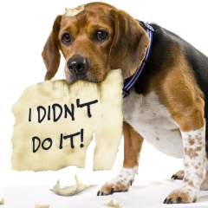
In a letter to Mr. Alioth, make up an excuse so dramatic or so funny or so outrageous that you just might be allowed to make it up tonight. Form:

Dear Mr. Alioth,
You’ll never believe . . .
Your student,
Doug

TC: What breed of dog is pictured here?

