Kindergarten Guide

School Phone 717-432-8691
School Building Extensions:
Dillsburg Elementary School – extension 1400
Northern Elementary School – extension 1500
Wellsville Elementary School – extension 1600
South Mountain Elementary School – extension 1700

Created February 2004
Revised October 2008

Mission and Philosophy
The Mission of the Northern York County School District, in cooperation with home and community, is to ensure that all learners are prepared to meet the challenges of today and tomorrow.

Kindergarten is a big step for your child. As your child experiences many new situations, he/she must make decisions on his/her own and function in an environment where challenges are always present. With cooperation from the home, it is our goal to meet the needs of each child using a variety of learning activities based on his/her developmental and intellectual abilities.

Kindergarten Student Goals

The student will feel responsible for his/her learning.

The student will develop the skill of learning how to learn.

The student will discover the excitement of the learning process.

The student will gain satisfaction from learning.

The student will develop responsibility for his/her own actions.

The student will develop the ability to think critically and solve problems.

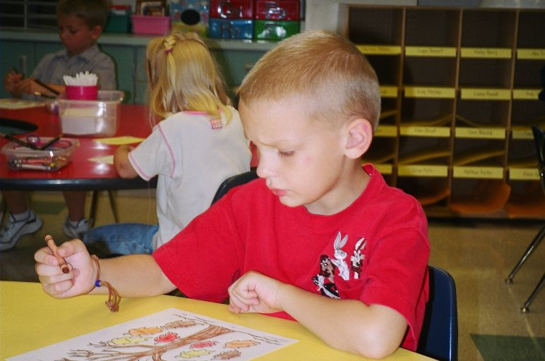

In the mail, parents will receive a Northern York County School District Calendar. It is a great source for school related information.

Parents can also visit our Northern York County School District web homepage to get information about the school district and visit individual teacher sites.
The address is www.northernpolarbears.com

Regular Kindergarten Hours:
AM class: 8:50 AM – 11:35 AM
PM class: 12:55 PM – 3:40 PM

Modified Kindergarten Schedule:
When a two-hour delay becomes necessary due to inclement weather, the following modified kindergarten schedule will be in effect:
AM class: 10:50 AM – 12:35 PM
AM class students are brought to school on the regular elementary busses on a two hour delay and delivered to the kindergarten stop one hour later than the normal scheduled time.
PM class: 1:55 PM – 3:40 PM
PM class students are picked up by the kindergarten buses one hour later than the normal scheduled time and are taken home on the regular elementary buses.

Act 80 Dismissal Schedule:
AM Class: 8:50 - 9:45AM
PM Class: 11:05 AM – 12:00 Noon

This year of school is very important for your child. The activities we will use, even those that look like play, are designed to teach the children skills needed for success in their school careers. The children are learning everything from reading and math skills to working well with others.

Kindergarten children spend much more of their day at home than they do at school. The parents are the child's first and most important teachers. Read to your child daily and play games. Work puzzles and color together. Help them get a good start to school!

As a child prepares to enter kindergarten, they should:

• Use the toilet properly and independently.
• Separate from parents willingly.
• Play cooperatively with same age peers.
• Wait for his/her turn.
• Walk up and down stairs using alternating feet

Before a child enters kindergarten, it helps to have exposure to and experience with:

• Reciting nursery rhymes
• Drawing a recognizable person
• Listening to books read to him/her daily
• Drawing and creating with pencils, crayons, scissors, and glue sticks
• Separating happily and willingly from a parent
• Greeting an adult
• Tying his/her shoes and zipping coats
• Cutting on a line with scissors
• Reciting his/her address and phone number
• Recognizing his/her first name and identifying its first letter
• Pointing to and saying, not singing, the alphabet
• Pointing to and counting set of objects to 10
• Identifying the 8 basic colors
(red, orange, yellow, green, blue, purple, brown and black)
• Identifying words that, when spoken by an adult, rhyme
• Building patterns

Help your child explore language by using these Boehm (bay-em) Concept Words when talking about things in his/her world:

Top, center, whole, side, last, medium-sized, always, right, corner, before, end, farthest, part, through, some, above, separated, first, row, few, next, every, bottom, never, beginning, second, front, widest, away, half, alike, fewest, match, over, as many, third, other, starting, most, behind, left, between, different, pair, below, skip, forward, least, backward, and equal.

For parents who want to help...

Kindergarten Orientation

Kindergarten Orientation is held just a few days before school begins at your child’s individual school.

At this evening program, the child:
• Is introduced to his/her teacher, puts a friendly face with a name, and gets to see his/her new classroom.
• Is introduced to the school principal and can explore the path to his/her new classroom.
• Receives his/her bus badge and important classroom information.
• Has the opportunity to ride a school bus with his/her parent and learn bus safety rules.
• Has the opportunity to use the class bathroom to be sure he/she can use it independently.

The parent:
• Is introduced to the teacher and receives important school information, and gets to see the classroom.
• Is introduced to the principal and has an opportunity to explore the kindergarten school area.
•Is introduced to the PTO, parent-teacher organization, and is welcomed to volunteer in our school.

Your family will receive a letter from NYCSD in August telling you the date, time and place for your child’s kindergarten orientation.

Meanwhile, in August, get in the school mode!

• Make earlier bedtimes and start a regular sleep/wake schedule.
• Buy a book bag/back pack for school. A regular-sized, functional book bag will work best. Please do not send kindergarten students with rolling wheel bookbags. Remember to empty the bag daily.
• Make a special spot in your house for school papers, important notes and schedules.
• Discuss your child’s new job…being a learner! Prepare them to do his/her best and listen carefully to the teacher.

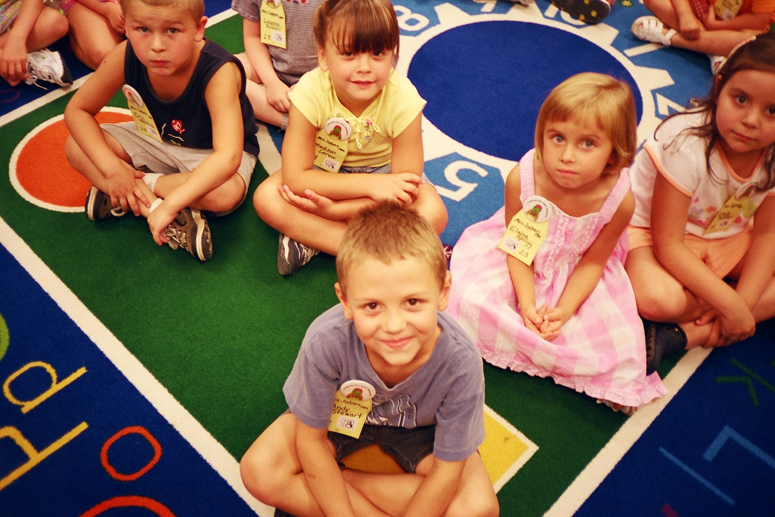

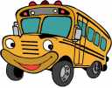

On the First Day of School,

• Put your child on the school bus!
It is easier for your child to leave you and go off to pleasant distractions, then for him/her to watch you leave and feel left alone as you go.

• Take important posed family photos before the bus arrives. Snap a few quick candid photos as your child gets on the bus.

• Have a quick, happy good-bye. Your smile and excitement about school help your child feel good about the new experience.

• Be sure your child wears the bus badge given to them by the teacher on Kindergarten Orientation evening.

• Be patient with the bus schedule the first two weeks of school. Learning bus safety rules and getting everyone into a new schedule takes a break-in period.

• When your child comes home, ask questions like these to get more details about your child’s school day.
Let’s look at what you brought home today (this could be papers, projects, etc.). Tell me about it.
Can you sing a song from school?
What friend did you play with on the slide (or other specific playground item)?
What was your favorite thing you did today?

Tips for a Great First Day of School!

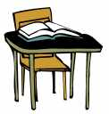
Absent? Parent pickup?

Absentee Verification Program
An Absentee Verification Program was implemented by the Board of Education in 1984. The purpose of the program is to identify students who are absent so that school officials and parents will know the whereabouts of all students.
On a day when your child is absent, parents/guardians are requested to call the school district automated attendance voice-mail system at 432-8691 at anytime before the beginning of the school day. After reaching the welcome announcement, callers should then dial the appropriate extension for their child’s school and leave their message when prompted. The elementary extensions are:
Dillsburg Elementary Ext. 5554
Northern Elementary Ext. 5555
Wellsville Elementary Ext. 5556
South Mountain Elementary Ext. 5557
School personnel will attempt to contact parents/guardians of students who are absent but not reported.

• Send an excuse slip, from the school district excuse book or from his/her doctor, to school the first day your child returns to school.

If you need to pick your child up from school,

• Send a signed, dated note to school with your child indicating the date of pickup, the person picking up the child, and the time of pickup.
• If it is an emergency and you can’t write a note, just call the school office (432-8691) or come to the school.

When picking up your child, please help keep our students safe and
help prevent traffic problems when picking up your child.
Give school buses the right of way.
Be aware of children walking around your car.
Go slow.
Your cooperation is appreciated!

Health and Safety

Health Screening:
The school nurses give all kindergarten children health screenings. Screenings for head lice, height, weight, vision, hearing, and dental may be included. Parents will always be informed of the results of the screenings.

Kindergarten Snack:
It is customary for kindergarten children to receive a snack each day. Northern York County Elementary Schools attempt to provide a nutritious snack to the kindergarten students.

At Kindergarten Orientation, parents will learn more information about kindergarten snack and will pick a drink for his/her child for the school year.

If you plan to bring or send a special treat for your child’s birthday, please make prior arrangements with the teacher. An unannounced treat can cause conflicts with snack time and the lesson plans for the day.

Hygiene:
Be sure your child can use the bathroom independently and properly before kindergarten begins.

Be sure your child knows proper healthy habits like:
covering coughs and sneezes with an elbow or tissue
using a tissue and throwing it away
keeping hands away from the face
washing hands with soap and warm water before eating and after play
flushing a toilet and properly using the bathroom

Safety:
Be sure your child knows bus safety rules!
• Keep your hands to yourself.
• Sit in your seat and face front.
• Talk quietly.
• Keep your book bag/back pack zipped.
For safety, it is best to have no toys, eating, pencils, etc. on the bus.
Cars should give school buses the right of way at all times.
Be alert for children around school buses.

Dress:
Dress your child in layered clothing and shoes designed for play.
Sturdy, closed toe/closed heel running shoes are highly recommended for school safety.
Label all removable clothing with your child’s name.



Curriculum Goals and Objectives for Kindergarten

The following pages include information about
our kindergarten curriculum for all academic areas,
our assessment procedures,
and our goals for January and June.
Communication Arts: Speaking and Listening

The student will use questioning skills to practice asking relevant questions of the teacher, guest presenters, and other classmates.
When given situation in a story, the student will use picture clues, text clues, and reasoning skills to determine if the story is reality or fantasy.
During discussion, the student will relate stories to similar personal experiences, predict outcomes of stories, retell stories in sequential order, and identify characters in stories.
The student will:
Stay on topic when speaking.
Use appropriate volume and pace when speaking.
Make eye contact with audience when speaking.
Give simple presentations (show and tell or other sharing activities).
Use oral language to work cooperatively.

While the teacher records ideas on a KWL (I Know, I Want to know, I Learned) chart, the student will practice using appropriate speaking skills while describing specific things known about a teacher chosen topic.
The student will:
Listen and share ideas during discussions.
Ask questions on the topic of the discussion.
Contribute information on the topic of the discussion.
Raise hand to participate in the discussion.
The student will use sentences to express needs, wants, ideas, and concerns to the teacher and other classmates.
The student will learn that computers, tape players, VCRs, overhead projectors can help teach new information, solve problems, entertain, show pictures, play music, etc.

The student will understand that there are other languages being exposed to simple songs (Frere Jacques), counting, and greetings (Bon Jour, Guttentag, Adios) in other languages.
The student will:
Be exposed to the idea that quotations or speech bubbles indicate dialogue in a story.
Find and circle quotations in Breakthrough to Literacy Take Me Home books.
Point to or frame quotations in Big Books during shared reading.
Use speech bubbles in journals or art projects to have a person in a story or picture say something.

The student will learn kindergarten basic words to say, read, write, and use in sentences.
KINDERGARTEN WORD LIST
red, orange, yellow, green, blue, purple, brown, black,
zero, one, two, three, four, five, six, seven, eight, nine, ten
a, and, away, big, can, come, down, find, for, funny, go, help, here, I, in, is, it, jump, like,

Communication Arts: Reading Skills and Concepts of Print

The student will look at book illustrations and make predictions about the story during teacher read aloud time.
The student will:
Point to the front and back cover and the top and bottom of a book.
Point to the title of a book.
Point to the spot where you start reading on a page.
Point to the first and last page of the book.
Point with finger to words using left to right progressing and return sweep.
Frame, with fingers or index cards, the first and last word on a page.
Frame one letter, then two letters.
Frame one word, then two words.
Frame the first, then last letter of a word.
Frame a capital letter.
Frame a period, an exclamation mark, question mark, and quotation or talking marks.
The student will:
Name a letter when it is shown.
Say the alphabet without slurring LMNOP or adding AND to X, Y, Z.
Print capital and lower case letters.
Arrange letters in alphabetical order.
Say the letter name of a beginning sound of a word when given an oral prompt.
Practice listening to a teacher prompted sentence and writing sounds for the words.
Circle, underline, or box a common sight word from the basic kindergarten sight words in text.
See teacher-modeled simple sentences and discuss what conventions build a sentence.
Use sight words to build simple sentences.
Use kid writing to practice writing a simple sentence.
The student will look at pictures inside the book the teacher is reading and answer question to make predictions about the story’s progression.
When shown a list of the basic kindergarten sight words, the student will read as many as possible.
In a 3-minute period of time, the student will write as many words as possible from memory. The teacher may prompt by suggesting words to write from categories like color words, story words, names of family members, animal names, etc.
The student will hear new vocabulary from the teacher and stories. Any unfamiliar words to the student will be discussed and explained.
The student will:
Name things or events that could really happen to them or others.
Name things or events that are considered make-believe or imaginary.
The student will reread a familiar text using expression to make it sound the way we talk.
The student will listen to a teacher read an informational text. After discussion, the student will answer the teacher’s questions on the topic using important information gained from the story.
The student will listen to the teacher describe the elements of informational text as fact or truth and fiction as fantasy or make-believe.
The student will listen to songs, stories, informational material, word families, or rhyming words on video, cassette, CD’s, or computer.
The student will draw pictures to illustrate stories.
The student will listen to informational, narrative, make-believe, and rhyming books.
The student will name characters, describe a setting, and tell what happened at the beginning, middle, and end of a story.
The student will look at a group of three pictures and name the two that rhyme.
The student will repeat phrases or sentences that are repetitive in stories, charts, or songs.
The student will identify likenesses and differences when comparing sentences with similar word patterns.
The student will listen to predictable books and orally complete a logical omitted word.
The student will role-play, use puppets, or stuffed animals to retell a familiar story.
After the teacher reads a story, the student will express feelings, thoughts, or impressions orally or through art.

Communication Arts: Writing
Do you remember how excited you were when your child began to talk? You celebrated your child’s cooing and baby talk; praised your child’s early attempts at speaking; and spoke to your child so that he/she could hear the correct pronunciation of words. In those ways, you joyfully taught your child to speak.
You can support your kindergarten child’s attempts at writing. You can model writing and its use in the home. Tell your child what you are writing and why when you write shopping lists, letters, and reminder notes. Praise your child’s early attempts at writing. Learning to write should be as free of risk and worry as learning to talk.
As kindergarten children learn to write, they progress through these developmental phases.
- Observation of written print
- Scribbling
- Making horizontal shapes across the page
- Drawing pictures to represent words
- Making repetitive shapes representing letters
- Making letters in random strings across the page
- Writing the correct beginning sound for a word (C=cat)
- Using phonetic/developmental spelling (teacher = techr)
- Putting spaces between words and forming sentences
- Using correct/conventional spelling (teacher = teacher)

The student will illustrate and kid-write a story about something that is personal to the student using one or more letter sounds per word.
The student will write or draw about a favorite thing.
The student will tell personal stories with a continuous theme or thread that narrows the focus of the story to a specific topic.
The student will use visual organizers (ex. webs) to limit content to specific topic.
The student will be exposed to brainstorming as a way to discuss and imagine ideas related to selected topic.
The student will brainstorm ideas about a selected topic for the teacher to place on a visual organizer.
The student will put story parts in logical order when give picture cards, mixed up story boxes, and when retelling stories.
The student will learn that questions can help you learn more about something or figure out things you don’t understand.
Initially, the student will practice stating a sentence formula (I want to know more about _________) to build questioning skills. Later, the student will ask questions that begin with who, what, where, when, why, or how.
The student will improve writing according to teacher directions:
Stretch words to hear more sounds to write.
Space words with fingers or objects.
Start sentences with capital letters.
End sentences with punctuation.
Emphasize page organization.
Attend to the directionality of writing.
Insert adjectives to add detail to a simple sentence.
Correlate illustrations to sentence details.
The student will become comfortable with the process of making conversions from kid writing to conventional writing through teacher-modeled sentences.
The student will practice writing teacher-modeled sentences that demonstrate the use of upper and lower case conventions, word spacing, and end mark punctuation.
The student will experience a nurturing, encouraging environment in which he/she becomes comfortable sharing work with classmates.

Mathematics
Sort and Classify-
Identify positions:
top, middle, bottom, in front, behind, over, under, on, inside, outside, left, right
Compare same and different
Sort by color, shape, and size
Identify characteristics by which items are sorted

Patterns-
Demonstrate rhythm and movement patterns
Identify patterns by color, shape, and size
Complete a pattern
Create pattern

Shapes and Sorting
Identify shapes in the real world
Identify circles, squares, rectangles and triangles
Describe attributes of plain shapes (flat shapes)
Recognize equal parts
Identify space shapes: cube, sphere, cylinder, and cone
Describe attributes of space shapes
Create space shapes

Exploring Numbers -
Count forward and backward (numerals to 30)

Identify equal groups
Identify more and fewer
Identify a number that is one more than another number
Identify a number that is one less than another number
Identify groups of things in sets of 0 to 20
Write numerals 0 to 30
Order numerals 0 to 20
Identify ordinal numbers - first, second, third, fourth, fifth, sixth, seventh, eighth, ninth, tenth
Explore larger numbers to 120

Time and Money-
Put events in order
Distinguish events that occur at different times of day
Determine things that take more and less time
Tell time with analog and digital clocks to the hour
Identify penny, nickel, dime, quarter

Measurement -
Explore, sort, compare, order, and measure by length
Explore, compare, and order by weight
Explore, compare, and order by capacity
Use a bar graph

Explore Addition and Subtraction-
Understand that two parts make a whole (2+2=4)
Identify and use the plus and minus sign
Find sums and differences
Solve addition and subtraction problems using toys (manipulatives) for the quantity of the numerals
Solve horizontally and vertically oriented addition and subtraction sentences

Science Social Studies Technology Music Art

Science –
In Biological Science, the students will study plants and animals and discover the characteristics of living and non-living things.
In Physical Science, the students will explore balls and ramps to discover how objects move.
In Earth Science, the students will observe and compare weather and seasons.
In Environment and Ecology, the students will study the topics of pollution and recycling. The students will also discover the movement, sources, and importance of water.

Social Studies-
The student will become acquainted with the world around them through the study of Self-Awareness, Friendship, Emotions, Family Units, Heritage, Basic Needs,
Community Helpers, Citizenship, American Holidays, and Our Earth.

Technology-
Computer technology is integrated in the kindergarten curriculum. The student will learn to operate the computer as a meaningful learning tool.

Music -
Learn to appreciate different types of music.
Find singing voice.
Build a repertoire of familiar songs.
Develop the ability to follow steps in singing games.
Improve auditory skills and memory skills by learning words to songs.
Develop the ability to move to a rhythm pattern.
Art-
Learn to use art materials such as crayons, paper, paint, glue sticks, etc.
Cut accurately
Develop creativity
Learn to appreciate creative work of others.
Learn to enjoy creating things and take satisfaction in his/her accomplishment.

Physical Development Handwriting

Physical Development

The student will improve gross (large muscle) motor coordination by walking on balance beams, skipping, hopping, participating in rhythm activities, and other large muscle activities.

The student will improve fine (small muscle) motor coordination by cutting, gluing, coloring, writing, drawing, and other activities.

Handwriting

The students will be instructed in the Peterson Directed Handwriting system.
Parents can also learn more about this handwriting program at the Peterson Handwriting Web Site.
The web address is www.peterson-handwriting.com

Assessment

Informal assessment is conducted every day in the kindergarten classroom. By watching the accomplishments and growth, as well as, struggles and challenges of students, the teacher can prepare a sound educational program for each student.

Parents can do their own type of informal assessment by talking with the child about his/her school day. Each day, talk with your child about schoolwork and the lessons studied at school. If your child isn’t eager to tell you what went on that day, try talking before bedtime and asking specific questions. For example: What did you do with kids on the playground today? Where did you sit on the rug today? What was the animal/character in the story today? What letter did you see at school today? Tell me something nice a friend did for you today.

When formal assessments are given to kindergarten students, the teacher promotes a relaxed, confident atmosphere. Testing is completed on an individual one-to-one basis by the classroom teacher or school reading teachers.

Three ways to help your child on school assessments:
Give your child a breakfast and or lunch filled with healthy foods.
Be sure your child has adequate rest.
Provide encouragement. Give your child the feeling that he/she can do it.

Parent teacher conferences are held with all kindergarten families in November to update parents on the progress of the student and provide information on areas to practice.

If, at other times during the school year, you have concerns about your child’s progress and wish to have additional parent teacher conferences, please send a note to your child’s teacher to schedule an appointment.

At the end of the second semester and fourth semester, the kindergarten students will receive a report card.

The next page is an outline of the items on the kindergarten report card and the goals set for the kindergarten students.

Items on the Kindergarten Report Card

Test Name | Test Description | Goals
Test Name | Test Description | for Jan | for June | for Advanced
Letter Identification | The student identifies uppercase, lowercase, and typeface a and g shown in random order. | 48 | 52 | 54 lettters
Word Recognition | From the Kindergarten Word List (see page 8), the student reads as many words as possible. | 20 | 40 | 54 words
Sound Identification | The student is shown lowercase letters in random order. He/she produces the letter’s sound. The student receives a point for each consonant and short vowel sound produced. | 18 | 22 | 26 sounds
Spelling Test | The student correctly spells: a, I the, red, is, see, can, said, my, it, six, me, look, go, to | 6 | 12 | 15 words
Dictated Sentence | The student listens to sentences read slowly and writes the letters for the sounds he/she hears. | 18 | 35 | 42 sounds
Rote Counting | The student must count aloud by ones. The score recorded indicates the last number said before an error. | 50 | 100 | counts to 120
Count Objects | The student must touch and count objects aloud. The score recorded indicates the last number said before an error. | 10 | 20 | counts to 30
Write Numerals | The student writes numerals from memory in sequential order. Reversals are accepted if they do not affect place value. The score recorded indicates the last number correctly written before an error. Possible score 30. | 10 | 20 | writes to 30
I can do it! Checklist
SECOND SEMESTER (Feb to June) GOALS
Identify Numerals
identifies all numerals 16 to 30
Identifies Coin Names
penny, nickel, dime, quarter
Puts Pictures in Sequential Order
uses a logical order showing beginning, middle, and end
Tells Time to the Hour
tells time to the hour on a clock with hands (8 of 12 hours)
Adds with picture help and without picture help
Subtracts with picture help and without picture help
I can do it! Checklist
FIRST SEMESTER (Aug to Jan) GOALS
Identify Colors
red, orange, yellow, green, blue, purple, brown, black
Identify Shapes
circle, square, rectangle, triangle
Identify Numerals
identifies all numerals 0 to 15
Sorts Objects
sorts a set of items in a logical way that the student names
Makes a Pattern
create a pattern that repeats at least three times

SECOND SEMESTER (Feb to June) GOALS

