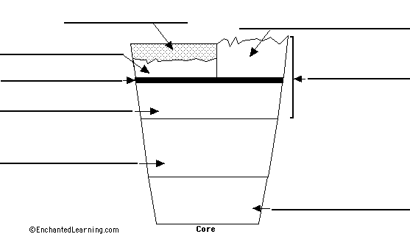
A Slice of the Earth

Continental Crust – the thick parts of the Earth's crust, not located under the ocean, made of rock
Ocean - large bodies of water sitting atop oceanic crust
Oceanic Crust – thin parts of the Earth's crust located under the oceans
Moho - separates the crust and the upper mantle
Lithosphere - the crust plus the rigid, upper mantle, cool layer of rock
Upper Mantle (rigid) - the uppermost part of the mantle, part of the lithosphere
Upper Mantle (flowing) = Asthenosphere - the lower part of the upper mantle that exhibits plastic (flowing) properties. It is below the lithosphere (the crust and upper mantle), between about 100 and 250 km deep. This usually has higher temperatures than the Lower Mantle
Lower Mantle (semi-rigid) - the deepest parts of the mantle, just above the core
Core –Outer core is made of liquid iron and nickel, while the inner is made of solid iron and nickel

