Ratio Race
- Take turns spinning the spinner.
- Divide the number by 10.
- Record the quotient on the ratio table.
- The first player to complete the table wins.

Player’s Name: Player’s Name:
n | n ÷ 10
10
20
30
40
50
60
70
80
90
100

n | n ÷ 10
10
20
30
40
50
60
70
80
90
100

Ratio Race ÷10 Spinner
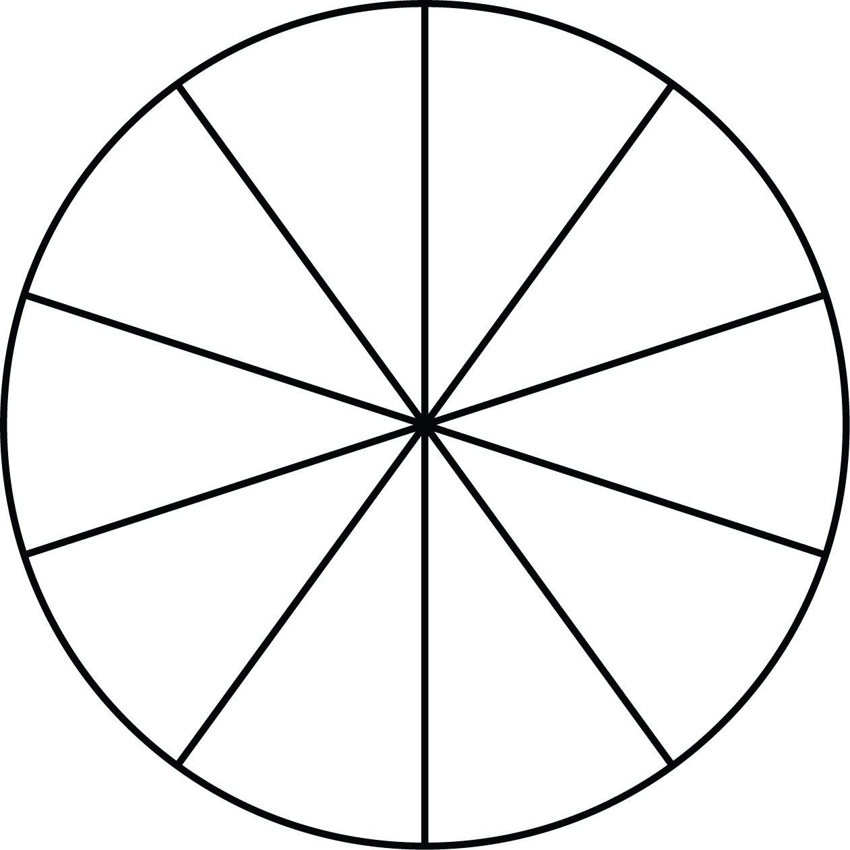
÷ 10
10
30
400
50
20
100
80
70
60
90

