Name:_______________________________________ Date:_____________

Section: (Grade, Period)_________________________

Knowledge about health can be one of the biggest favors you can provide as a service for yourself and as an active member to society.

Your job is to report on a current health news topic within the past year. It can be on anything health related as long as it comes from a credible source. <Use LibGuides and the sources provided>

Use the link to create your VERY OWN NEWSPAPER ARTICLE! <Link is found on my website & LibGuides>
http://www.fodey.com/generators/newspaper/snippet.asp
GUIDELINES
- Topic must be health related <see examples, but you are not limited to just those>
- Topic must be within the past year <see me if you would like to present a health topic that is older>
- A minimum of a paragraph must be written about your topic<5+ sentences>
- A copy OR a works cited of the source(s)
- Must be in the format of a Newspaper Article <see example on left>
- Topic must be presented on your scheduled date <see sign-up sheet>
- Turn in a self-graded rubric (back page of packet) along with your presentation

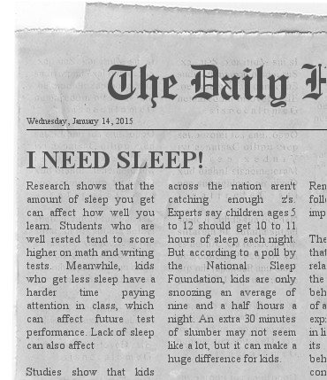

Attached are
- Credible sources <not limited to>
- Example of recent health news topics <not limited to>
- Self-Graded rubric

**Team Time, Resource Time, library, and class time passes may be granted upon request to complete assignment in school. However, this is an out-of-class assignment.

My date to present is:_______________

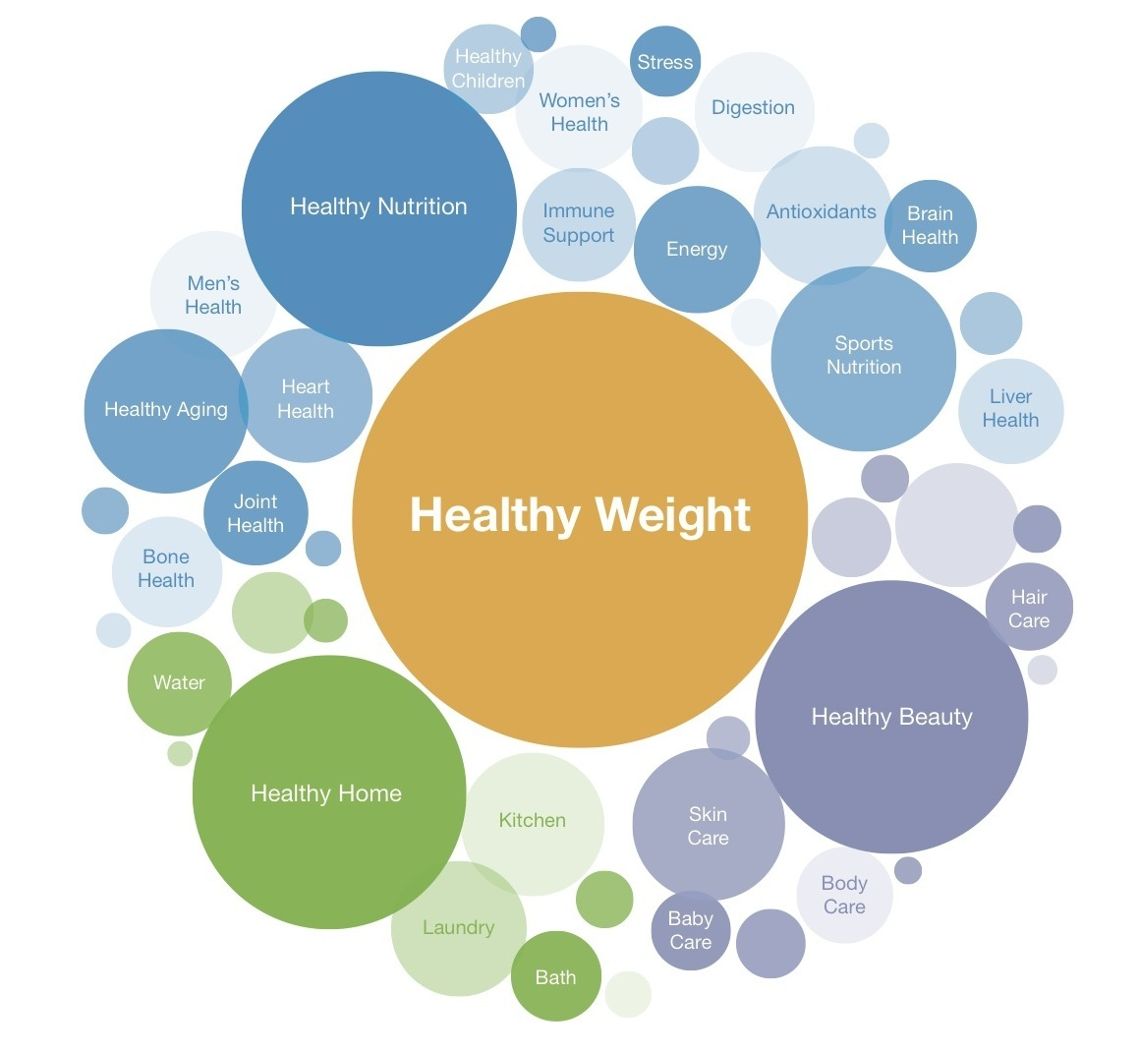

- Ebola outbreak | - Yoga
- Drug/Alcohol/Substance abuse | - Disabilities
- Trends in illegal drug use | - Hygiene
- Asthma control | - Plastic surgery
- Anthrax | - Medicine
- Injuries | - Soda
- Salmonella/food poisonings | - Dark chocolate
- Food/medicine recalls | - Sugar substitutes
- Food allergies | - Hand sanitizer
- Food safety | - Colon cancer
- School breakfast/lunch programs | - Breast Cancer
- Diabetes | - Leukemia
- Health Care/Affordable Health Coverage Act | - Depression
- Noise-Induced hearing loss | - Relationships
- Influenza/vaccines | - Gender
- Mental health | - Autism
- Physical activity | - Blood sugar
- Obesity | - Health research
- Risk behaviors | - Nicotine
- Skin cancer/other cancers | - Smokeless cigarettes
- Immunizations/vaccines | - Attention Deficit Disorder
- Young/adolescent workers, safety | - Families
- Diseases | - Human body
- Tobacco use | - Human growth
- Hunting safety | - Bullying
- Heart health  - Other:______________________________ | - First Aid/CPR/AED  - Other:___________________________



- National Cancer Institute – http://www.cancer.gov
- American Academy of Pediatrics – http://www.aap.org
- American Heart Association – http://www.heart.org
- American Lung Association – http://www.lung.org
- American Medical Association – http://www.ama-assn.org
- American Public Health Association – http://www.apha.org
- National Education Association – http://www.nea.org
- United States Department of Agriculture – http://www.usda.gov
- Nutrition.gov – http://www.nutrition.gov
- Centers for Disease Control – http://www.cdc.gov
- Action for Healthy Kids – http://www.actionforhealthkids.org
- National Institute of Health – http://www.nih.gov
- Mayo Clinic – http://www.mayoclinic.gov
- Health – http://www.health.com
- American Diabetes Association – http://www.diabetes.org
- American Council for Drug Education – http://www.acde.org
- Choose My Plate – http://www.choosemyplate.gov
- American Red Cross – http://redcross.org
- Department of Health and Human Services – http://hhs.gov
- Drug Education Council – http://www.drugeducation.org
- Newspaper articles
- Magazine articles
- Textbooks
- Other:__________________________________________

Name:_______________________________________ Date:______________
Section: (Grade, Period)_________________________

5 points each | DESCRIPTION | YES | NO
Topic | Topic is health-related
Current | Topic is within the past year
Paragraph | Paragraph is a minimum of 5 sentences & summarizes topic
Sources | Topic was reported from a credible news source(s) & provided
Execution | Topic was presented on scheduled date
Newspaper | Prepared assignment using Newspaper link

Self-Graded Rubric Instructions: Prior to delivering your presentation, review rubric and check either “YES” or “NO”

Total Points: ______/30___
Comments:_______________________________________________________________________________________________________________________________________________________________________.

