Name: ______________________________ 6th Grade Health
CS Section: _________________ Study Guide Packet

Personal Health Unit

Unit Essential Questions
1. What are the parts of the eye, ear, tooth and skin and how do they work?
2. What personal care practices will help keep the body healthy?

Healthy Ears (p. 153-154)

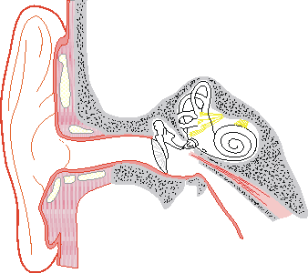
Relay vibrations deeper into the ear

Begins to vibrate as
sound waves hit against it
Changes the vibration into nerve impulses

Carries the nerve impulses to the brain
Connects to the throat and helps keep the air pressure equal on both sides of the eardrum

Page 2

Hearing Problems – Can be caused by:

1. ___________________________________________

2. ___________________________________________

3. ___________________________________________

4. ___________________________________________

[Decibels – a unit for measuring the loudness of sound]

Protect your ears from

___________ _________

Turn down the volume
Wear earplugs
Do not insert any

into the ear
Wash your ears to prevent a build up of

_______________ and

__________________
Protect your ears from the

________________ by

wearing hats or ear muffs

How to Have Healthy Ears

Page 3

Healthy Eyes (p. 151-152)

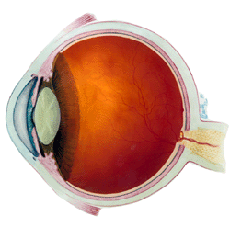

Nerves on the back of the eye that change light into nerve impulses
Clear covering on the front of the eye

Opening for light to enter the eye

Carries messages to the brain

Controls pupil size
(the colored part)
Focuses light on the retina

In what order do signals pass through the eye to the brain?

1. ___________________________

2. ___________________________

3. ___________________________

4. ___________________________

5. ___________________________

Page 4
Eye Problems – can be corrected with glasses or contact lens

Can see far away objects
Close objects are blurred

Can see close objects
Distant objects are blurred

Have ________________

every 2 years or when you have problems

Protect from_____________

Wear sunglasses and
Safety goggles

Protect from ____________
Use good lighting
Take a break from the TV, computer or reading

Don’t ______________ your
Eye if something gets in it.
Rinse it with cool water.

How to Have Healthy Eyes
Page 5
Caring for Your Teeth & Gums - (p. 145-147)

Parts of a tooth:

blood vessels & nerves

Common Dental Problems

________________ -
a decaying hole in a tooth

___________________ disease –
is a disease of the gums

Life of a cavity:

1. ___________________________ - a sticky film which forms on the teeth

2. __________________ form when sugar combines with bacteria in plaque

3. Acids wear away a hole in the ____________________ of the tooth

4. A dentist repairs the hole (cavity) with a _______________________

Page 6
HEALTH LAB - What Makes Cavities?

Procedure: 1. Distribute eggs in cups (eggs have soaked for several days in vinegar prior to class)
2. Have a member from each group drain off the vinegar and take the egg to their table
3. Roll the egg unto paper towels
4. Allow each member to examine it carefully
**Warning do not poke at the egg……. Handle with great care!!**

Follow-up questions:
1. How is the egg shell like the enamel of your teeth?

__________________________________________________________________

2. The acids in the vinegar caused what changes in the egg shell?

__________________________________________________________________

3. What conclusions can you draw about the effects of acids forming in your mouth?

____________________________________________________________________

p. 146-147

- ________________________ and ________________________ daily.

- Choose foods with lots of ______________________________.

- Cut down on foods with ____________________________.

- Use toothpaste with __________________________________________.

- Have checkups and cleanings every _______________________________.

- Consider ________________________if your dentist recommends them.

- Wear ________________________________________ for sports.

Page 7
Keep Yourself Looking Good

Looking Your Best ( p. 144)

“__________________________” - actions that maintain a clean, healthy body

Products you can use to help with personal hygiene:

1. Skin care - _________________________ ____________________________

2. Hair care - _________________________ ____________________________

3. Nail care - _________________________ ____________________________

Get Your Sleep (p. 196)

You need ____________________ hours of sleep each night to be alert the next day!

When you sleep: 1. Your heart and breathing _________________________ down

2. Your brain remains ______________________________

3. Body cells repair and __________________________________

Dress for Success!

- Choose clothes that give you a pleasant appearance.

- Choose clothes that are the correct size.

- Follow family guidelines for borrowing or sharing clothes.

- Do not wear clothes which display bad language, drugs or rude behavior.

Page 8
Caring for Your Skin, Hair and Nails - (p. 147-150)
Parts of the Skin

________________
openings in the skin for hair, oil and sweat to come out

________________
the outer layer of skin

_________________
the inner layer of skin contains nerves & blood vessels

Some common health problems:

Acne – clogging the pores with oil and bacteria…creating blackheads and pimples
Warts – small, hard growths on the skin

Dandruff – a flaking of the outer layer of the scalp (skin on the head)
Head Lice – tiny insects which lay eggs (called nits) in human hair

Chewing Nails – causes damage to the skin and looks bad

Ways to take care of your skin, hair & nails include:

- Wear a _____________________________________ with a SPF of at least 15 or clothing to protect the skin from UV rays.

- _______________ or _____________________ every day to remove germs, dirt and oil.

- Apply _________________________ after bathing and before getting dressed each day.

- Use a gentle shampoo and ________________________ when needed.

- Use a special ____________________________________ if you have dandruff.

- See a _________________________________ (p. 148) if you have any skin problems.

- Keep you nails trimmed and clean under them.
- Eat a healthy diet.
Page 9
Nutrition & Exercise

“MyPlate” --- is a guide reminding us to eat each food group at every meal.

Read textbook p. 100-101
(Warning: the book uses the old food pyramid picture, but the groups are the same.)
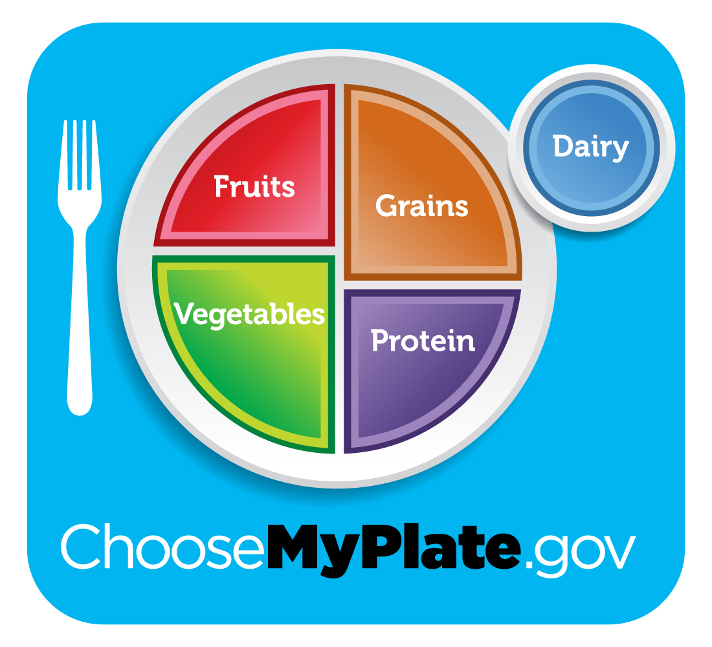

Benefits of Physical Activity: (Read p. 120-122)

**Teens should get ______________ minutes of exercise every day.

Regular exercise helps:
1. Helps burn _______________________ for good weight control.

2. Helps prevent diseases like__________________ and ______________________.

3. Strengthens the ____________, ______________, _____________ and ________.

4. You have more ________________, sleep better, and reduce_________________.

5. It is fun to do with friends and family!!!
Page 10
Guidelines for Healthy Eating: p.103; 105- top of 107

Eat a variety of food.
Control the amount you eat.
Be physically active.
Eat more fruits, vegetables & whole grains.
Eat less salt, sugar and fat.

Making Good Food Selections - Activity

High Fat vs. Low Fat

1. _____________________________ vs.______________________________

2. _____________________________ vs.______________________________

3. _____________________________ vs.______________________________

4. _____________________________ vs.______________________________

High Sugar vs. Low Sugar

1. _____________________________ vs.______________________________

2. _____________________________ vs.______________________________

3. _____________________________ vs.______________________________

4. _____________________________ vs.______________________________


Start your day with a healthy breakfast!

