Name: _____________________ 6th Grade Health
CS section: ___________ Personal Health Unit

Review Sheet #1 - Eyes, Ears & Teeth

Label the Diagram: Using the word bank label the parts identified on the diagrams.

Eye - word bank: pupil, cornea, optic nerve, lens, retina, iris

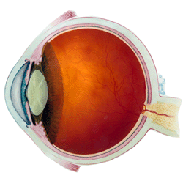

Ear - word bank: Eustachian tube, ear bones, cochlea, ear drum, auditory nerve

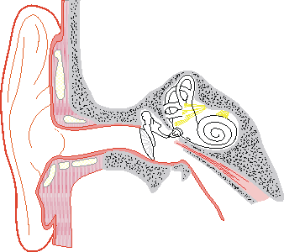

Continue to complete the work on the back…..
Page 2
Fill in the term - Use your notes to find the correct term for each description.

____________________________ 1. A tube connecting the ear to the throat

____________________________ 2. Begins to vibrate when sounds waves hit it

____________________________ 3. Carries impulses from the ear to the brain

____________________________ 4. Focuses the light entering the eye

____________________________ 5. The black hole where light enters the eye

____________________________ 6. Carries impulses from the eye to the brain

____________________________ 7. The outer surface of a tooth

____________________________ 8. A disease of the gums

____________________________ 9. What causes cavities in teeth

1. List 2 things you should do to take good care of your ears.

a. _____________________________________________________________

b. _____________________________________________________________

2. List 2 things you should do to take good care of your eyes.

a. _______________________________________________________________

b. _______________________________________________________________

3. Describe 2 things you should do to care for your teeth.

a. _______________________________________________________________

b. _______________________________________________________________

