Name __________________ Period _____ Date _______
3. Increased amounts of natural radio waves

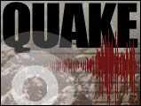
Predictions
For Earthquakes
1. Changes in scientific instruments
5. Ability of crystal rock to conduct electricity
4. Changes in Earth’s magnetic and gravitational fields
2. Rock formations swell
10. Crazy animal behaviors
8. Micro-eq. or minor tremors
7. Changes in water level and temp. of deep wells
6. Increased amounts of Radon
Seismographs, tiltimeters, laser beams
9. Geysers off schedule
Dogs bark constantly, fish swim frantically. Rats leave houses
11. Changes in tilt of rock slabs

