Name: ____________________________________ 6th Health Ed.
CS Section: ________________________ Study Guide Packet

Body Systems

Unit Essential Questions:
1. What are the names and locations of body organs?
2. How do body systems work?
3. What are ways to care for your body systems?

Building Blocks of the Body (p.176-177)

__________________ __________________ ____________________

A._______________________:
- Cells are the smallest parts of the human body.
- Different cells have different shapes and different jobs.
- Cells need food and oxygen to help them grow and work.

Examples of cells - ________________________ ____________________________

B._____________________________:
- An organ is a group of cells that work together.
- There are many different organs working in the body.

Examples of organs - ________________________ ___________________________

C.____________________________________:
- A body system is a group of organs that work together to do the some job.
- Each body system does a different job.

Examples of systems - _________________________ _________________________
(p. 178)
__________________________ _________________________

Page 2
The Nervous System (p. 192)
-- is the ____________________________________________

A.______________________
The brain is the control center of the body.
Different parts of the brain do different jobs.

B.________________________
Cells which carry electrical messages to all body parts
Some nerves carry messages to the brain. Others carry messages out to body organs.

C. ________________________________
A thick bundle of neurons that runs along the spine (down the neck & back bones)

*_____________________* (not in book)
- A quick movement that happens before the brain has time to think.

Caring for My Nervous System

1. Use a ______________________ _______________________ when riding in a car.

2. Wear _____________________ ______________________ for sports.

3. Follow all safety _____________________________.

4. Never use alcohol or _________________________________.

Page 3
The Circulatory System (p. 188-190)
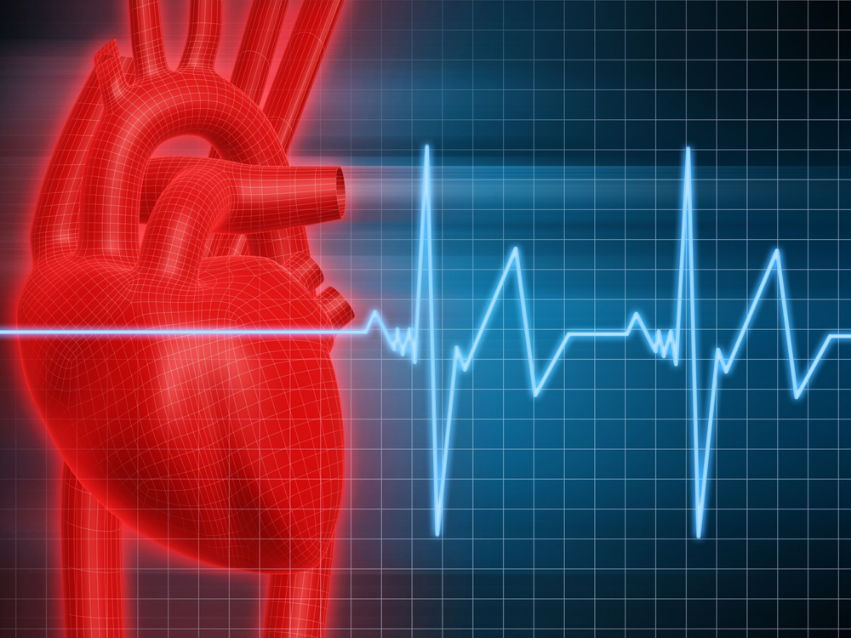 -- allows the body __________________________ to tissues

Heart: _______________________________________________________
Pushes blood through the blood vessels

Blood Vessels:
________________________ - carry blood away from the heart

________________________ - return blood to the heart

______________ __________________ - force of blood pushing against the vessel walls Too much pressure can be very dangerous

________________________ - is the speed the heart beats.
Exercise, stress and some drugs can make the heart beat faster.

Parts of Blood:

1. __________________________________ – liquid part of blood

2. __________________________________ – carry oxygen to body cells

3. __________________________________ – destroy disease germs

Caring for My Circulatory System

- __________________________________ to keep the heart muscle strong.

- Eat fewer _____________________________ foods to keep the blood vessels clear.

- Do not ____________________________________ tobacco.

- Keep your body at a healthy _________________________________.
Page 4
The Respiratory System (p. 191)
-- enables you to ________________________
All body cells need oxygen from the air you breathe

What steps allow us to breath?

1.______________________________ muscle: controls breathing in and out.

When the muscle pulls down you breathe in – __________________
When the muscle moves up squeezing the lungs you breathe out -_______________

2. _________________________________:
Air flows from the mouth and nose down this tube in the neck.

3. __________________________tubes: Two tubes leading inside the lungs.

4. _________________________ - tiny air sacs covered by capillaries
Where oxygen enters the blood and carbon dioxide is removed.

Caring for My Respiratory System

1. Stay away from _________________________ areas.

2. Do not ________________________________tobacco and avoid breathing in tobacco smoke.

3. _____________________________________ to strengthen breathing muscles.

Page 5
The Skeletal System (p. 181)

-- is the body system consisting of______________________________________________
There are 206 bones in the skeletal system.

3 things the skeletal system does:

1. __________________________________________

2. __________________________________________

3. __________________________________________

____________________________ - a place where 2 bones come together (p. 182)

_____________________________ - tissues which connect bones holding them together
(NOT in book)

Caring for My Skeletal System

- ________________________________ to make bones thicker and stronger.

2. Eat or drink plenty of ______________________________ and vitamin D (in milk).

3. Wear shoes with good ____________________________ support.

4. Sit and stand with good _________________________ to support the spine and back.

Page 6
The Muscular System (p. 183)

-- made up of _________________________________________

They allow us to move, pump blood, breath and move food.

How do muscles help us move?

- Muscles connect to 2 different bones

- ____*Tendons*_______ at the end of the muscle attach it to the bone.

- When the muscle contracts (shortens) it pulls on the bones making them move.

- When the muscle relaxes (gets longer) the bones move back.

- Muscles work in pairs opposite each other - as one shortens the other gets longer.

Voluntary (skeletal) muscles - can control _________________ __________________

Involuntary (smooth) muscles – can NOT control ________________ ______________

Caring for My Muscular System

- Lift heavy objects by bending your _______________ and keeping the back straight.

- __________________________ during and after exercise.

- Eat foods with __________________________________ to help muscles grow.

Page 7
The Digestive & Excretory Systems (p. 185-187)

The Digestive System –
Controls the process by which your body __________________________________

“Nutrient” – is a substance in food that helps body cells and gives you energy.

What happens to food after you swallow?

1. Food passes from the mouth down a tube called the ___________________________

2. ____________________________ - produces digestive enzymes and mixes the food

3. Small __________________________ - long tube connected to the stomach
Breaks the food down and absorbs nutrients into the blood

4. Large__________________________ (colon) – absorbs water and holds solid waste

The Excretory System - gets rid of ___________________ from the body

What happens to liquid waste?

________________________ (2 organs) – filter blood and remove water & waste

_______________________ - the liquid waste that is stored in the bladder

Caring for My Digestive & Excretory Systems

1. Chew food completely before __________________________________.

2. Eat more ____________________ and _____________________________ to keep solid waste loose and passing out of the body.

3. Drink 6-8 glasses of _______________________________ every day.

