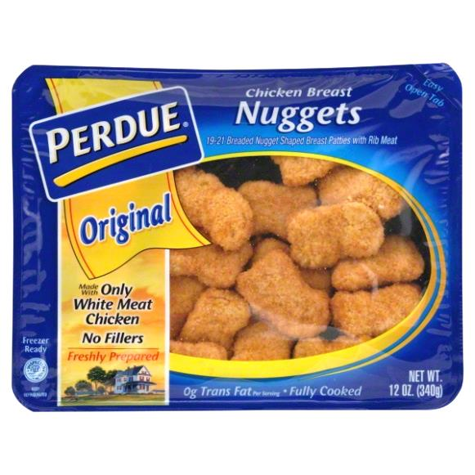 **1.3 Fundamentals of Marketing**

Market:

Consumer Market***:***

* Consumer “Wants”:  ***___________*** _, ***________*** _,  ***________________*** _ , ***_____________________***_, and ***_________________*** _

Industrial Market***:***

This market is also known as**:**

* Businesses “Wants”:  ***____________*** _,  ***____________*** _,  ***____________________*** ,  ***____________________*** _ , and ***_____________*** _
* Companies that produce products for resellers must consider ***_______*** different marketing plans to reach ***________*** markets.

Market Share:

**Activity:**

Look at your class as a whole. Imagine a company that sells class rings has targeted your class. What are some facts the company can use in its marketing effort to classify and target potential customers?

Market Segmentation:   
  
Target Market:

Why is identifying the target market important?

1. Define who you believe would be a target market for each of the following products.
2. Watch the commercial…Did the commercial target the market you thought it would?

**Toyota Sienna Hooveround John Deere Tractor Crest Oral B Toothpaste**

What is the difference between consumers and customers?

Customer Profile:   
  
The secret to developing a successful marketing campaign is to create an effective  
 **____________________** using **______________________________.**

**List and describe the 4 Ps in Marketing**

**1.) *P*** _  
_  
_

**2.) *P*** _  
_  
_

**3.) *P*** _  
_  
_

**4.) *P*** _  
_  
_

* The 4 P’s are based on the ***________*** viewpoint. A successful marketing campaign will focus on the ___***_______________*** perspective.
* The 4 P’s of the marketing mix focus on the ***__________________***  for a specific target market.

Before developing your 4 P’s, you should consider your 4 C’s. List and describe the 4 C’s (include the related “P” for each in parenthesis next to the “C”)

**1. Customer Solution** (Product) – Customers care more about solutions or satisfying their wants. _

**2. C** _

**3. C** _

**4. C** _