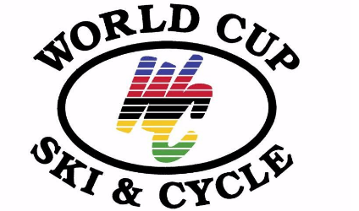**World Cup Ski & Cycle**

**3804 Gettysburg road**

**Camp Hill, Pa 17011**

**717-730-9402**

**Worldcupskiandcycle.com**

**Northern Middle School Ski / Snowboard Club is partnering with World Cup Ski and Cycle this year for some great equipment and services for our Members! To obtain these discounts, simply go to World Cup Ski & Cycle and let them know you are a member of the club.**

**Here’s a list of Special offers for our club:**

**Season Ski / Snowboard Lease –**

* These are high quality newer and better maintained than rentals.
* You keep this equipment all season.
* No waiting in rental lines. Equipment can be used on other trips.
* You can keep this equipment dry and clean since you are the only person using it.
* Equipment if freshly tuned with our Bronze Tuning package

**Ski Lease package** - Skis, Boots, Poles.

Youth package - $175 - Normally $200

Adult package - $225 - Normally $300

(Youth or Adult is determined by skier size not by age, approximately 120 lbs).

**Snowboard Lease package** – Boots and Snowboard.

 Youth package $175 - Normally $200

 Adult package $200 - Normally $250

**Helmets** - Helmet fit is extremely important to safety.  We will size each skier and adjust straps for each skier to obtain the appropriate fit.

Giro Ledge - $50. (Available in 7 colors) - Normally $60

Upgrade to Giro Nine $85. (Available in 8 colors) - Normally $100

**Bronze Ski or Snowboard Tuning Package** - $40

This includes a stone grind, minor base repair, sharpen and bevel edges, wax and brush. A stone grind creates a very flat / level ski base which combined with our consistent base and side edge sharpening makes the ski perform significantly better.  The skier will ski better when these tuning metrics are done well.  We also brush the ski properly after waxing, creating a much better gliding experience.  This is doubly obvious in soft or sticky snow.

**Binding Release Check** - $20

This sets the binding to correct specifications for height, weight, age, boot sole length, and ability.  This should be done every year.  This is especially true for growing kids whose weight, height and ability changes from year to year.  This is necessary to reduce the chance of injury.

**Ski or Snowboard Purchase Package** - We can offer a ski purchase package beginning at $595 (This is a $700 retail package), and a Snowboard package beginning at $450.   We can then customize the package as the club member desires.

**Ski or Snowboard Bag** - $30

**Accessories** - 10% discount off of our regular prices – (Available to lease purchaser during lease purchase visit only)