C:\Documents and Settings\teacher\Local Settings\Temporary Internet Files\Content.IE5\SDRJ2IJA\MC900299897[1].wmfSports and Entertainment Marketing – Syllabus

2018-2019 Northern York High School

Instructor: Mr. Kluck

[kkluck@nycsd.k12.pa.us](mailto:kkluck@nycsd.k12.pa.us)

**Course Description**

Sports and Entertainment Marketing is a unique and innovative course designed for students with an interest in the sports and entertainment industry. This course stresses the utilization of fundamental marketing concepts and will include an orientation to the sports and entertainment industry. Marketing strategies along with topics in sponsorship, pricing, marketing research, endorsements, and promotions will be part of this course.

*Virtual Business – Sports and Entertainment 2.0* is a highly visual computer simulation of a sports and entertainment venue that lets students handle promotions, ticket pricing, stadium operations and staffing, sponsors, concessions, concert booking and promotion, and more.

**Text and Resources**

Kaser, Ken, and Dotty Boen Oelkers. Sports and Entertainment Marketing. Mason, Ohio: South-Western Cengage Learning, 2005. Textbook.

Virtual Business – Sports and Entertainment 2.0 (Software)

**What will we be doing?**

Students will be responsible for organizing and operating the Northern High School Polarthon, Students will participate in the Philadelphia 76ers DECA Night and the Pittsburgh Pirates DECA Day. Students will have the opportunity to compete in DECA District, State, and National Sports and Entertainment Marketing Competitions. Students will be responsible for the promotion and operation of concessions, along with selling tickets, at several Northern High School sporting events. Throughout this course students will complete multiple mini-assessments entitled: Marketing Myths, Project Extra Innings, Take a Bow, Intermission, Time Out, Opening Act, Cyber Marketing, Winning Strategies, and Judgment Calls. Students will be assessed through a variety of Sports and Entertainment Marketing Projects (examples: Endorsement Project – Chicago Baseball Teams, Sports Sponsorship, Sports Fantasy Football Project, Sports and Entertainment Marketing-Music Downloads and Cyber Ethics Project, Sports and Entertainment Marketing-Sports Logo Project, Design a Stadium Project, etc.)

C:\Documents and Settings\teacher\Local Settings\Temporary Internet Files\Content.IE5\ATWUVN9S\MC900213091[1].wmf

**Units of Study:**

*What is Sports and Entertainment Marketing?*

*Sports and Entertainment Means Business*

*The Wide World of Sports and Entertainment*

*Hit a Homerun with Customers*

*Marketing-Information Management*

*The Marketing Game Plan*

*The Product is Sports and Entertainment*

*Choose the Channel*

*The Economics of Supply and Demand*

*Sports and Entertainment Promotion*

*Promotional Planning*

*Selling Sports and Entertainment*

*Sports and Entertainment Legal Issues*

*Creating, Owning, and Operating a Business*

**What is DECA?**

Membership in this organization will allow you opportunities to participate and to travel to the district, state and international level of competitions that have been scheduled for this school year. Your participation in this organization will also provide you the chance to be part of the many activities that your officer team will be planning.

**DECA Events:**

* Philadelphia Universtiy
* Philadelphia 76ers
* District Competion (TBA)
* State Competition @ The Hershey Lodges
* Harrisburg Senators and/or Pittsburgh Pirates
* National Competion in Orlando, FL (April 27-30)

**How will you be graded?**

Students will be assessesd through **Chapter Quizzes, Unit Exams, Chapter Projects, Note Checks, and Other Content Related Projects / Assignments**

**Make Up Work** --- Absent work will be due the day following your return to school. Any notes or assignments that you miss due to an absence are your responsibility, if you have any questions please let me know. If you need to schedule time before or after school to make up work please let me know. Work that you miss due to an absence can be found in the “Absent” bin located in the front of the room. If you miss a test due to an absence it must be made up upon your return to class (either during class, during a study hall, or after school).

**Late Work:**

* ALL work should be completed by its assigned due date, however, I understand that things happen (you forget to do it, you leave it at home, etc.). I will accept late work, with a 10% deduction for each day it is late, after ten days it will become a zero permanently.

**Classroom Behavior**

* Don’t allow cell phones to be a distraction! NOTE: If you are working on a project and using your phone to listen to music; I CAN tell the difference between texting and changing a song!
* Come to class ready to participate.
* No food or drink at the computers (follow school guidelines).
* Be on time to class every day. Skipping or chronically coming to class late will not be tolerated.

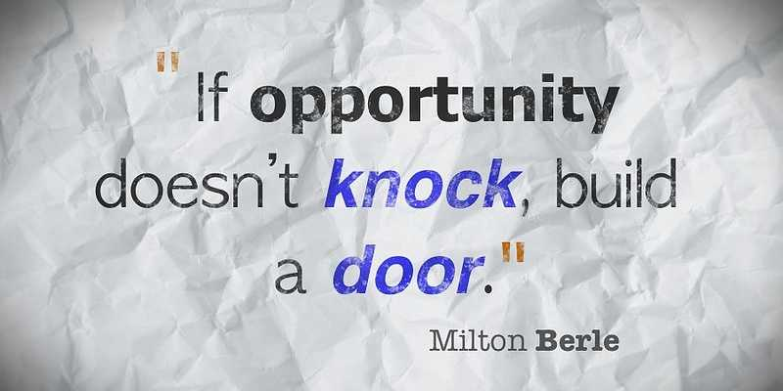

**Keys to Success!**

* Complete ALL assignments in a timely manner!
* Participate
* Take Notes
* Ask for help if you don’t understand something.
* Be creative!
* Do your own work!

