**Creative Candy Product  
Marketing Mix (4 P’s)**

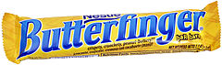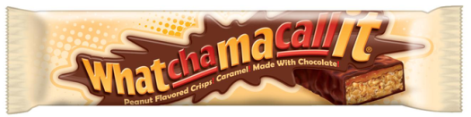  
**WARM-UP**

List a dozen business or product names you think are clever or especially like:

1.______________________________

2.___________________________ ___

3.______________________________

4.______________________________

5.______________________________

6.______________________________

7.______________________________

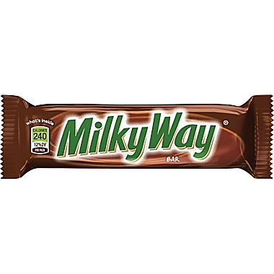8.______________________________

9.______________________________

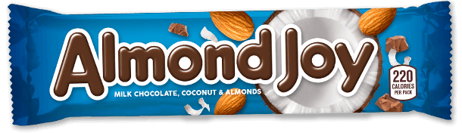10._____________________________

11._____________________________

12._____________________________

*How did these names come to be? Can you give the origin of any of these names?*

**CHALLENGE**:

1. 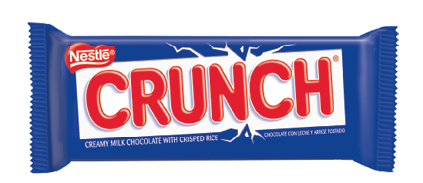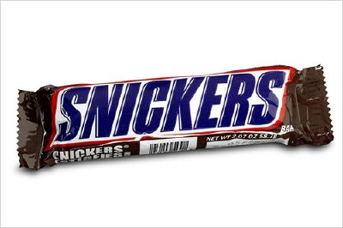You and your team (of no more than 3) will have 20-30 minutes to create a new candy bar that will appeals to people in the Dillsburg (Central PA) region. Use the piece of cardstock that you are given as a template for your new candy wrapper. You may also use any of the other materials provided. Things you must include with/on your candy bar wrapper.

* Give your candy a catchy name / slogan.
* Design a snappy-looking wrapper.
* Include a list of ingredients and the weight.
* What else might you include?

1. Work together to come up with a commercial; 45-60 seconds.

**PRODUCT**:

When time is up, your team will be asked to present your commercial “selling” your new candy product.

Include the basics of a good commercial:

* What’s for sale?
* 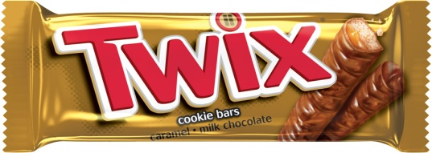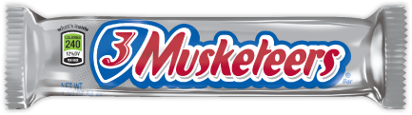Why the consumer should buy this candy?
* What’s special about your candy?
* WIIFM- What’s in it for me? Why should I buy YOUR candy bar? (feel free to exaggerate the powers of your bar!)