**Found Object Color Wheel**

Using objects you can find in your home and yard, create a color wheel. The objects can be related (all spools of thread) or unrelated (completely random objects that represent the colors you need). Photograph the color wheel and share it with me. Then clean up your mess!

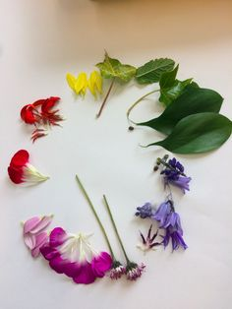 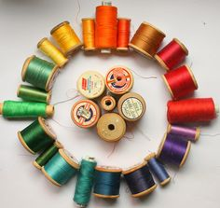

Bonus activity – create some basic color schemes with your objects