Marketing I

2018-2019 Northern York High School

Instructor: Mr. Kluck – Room 201

[kkluck@nycsd.k12.pa.us](mailto:kkluck@nycsd.k12.pa.us)

**Course Description**

Marketing I is a program designed for students who may have an interest in pursuing their studies in the fields of marketing, merchandising, management, and entrepreneurship. Students enrolled in this program have the opportunity to apply their marketing competencies to an international organization for marketing students, DECA. This organization encourages students to evaluate their marketing competencies in DECA’s competitive events program. Students can obtain further information about the competitive events through National DECA’s webstie: DECA.org.

**Textbooks**

*Marketing Essentials,* Farese, Kimbrell, and Woloszyk, Glencoe/McGraw Hill, © 2009.

**Course Schedule (Tentative):**

Week(s):

**1 – 3** **The World of Marketing –** Marketing Mix, The Marketing Plan, Market Segmentation, Seven Core Standards of Marketing, Economic Utility, Target Markets

**4** VR- Retailing

**5 – 6** **Developing a Business Plan / Financing the Business**

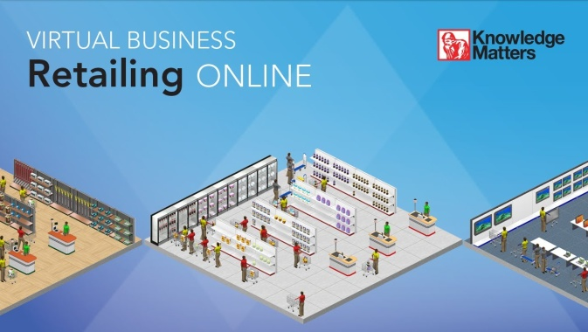**7** VB - Retailing (Continued…)

**8 – 10** **Skills for Marketing** – Basic Math Skills, Communication Skills, Technology Applications for Marketing, Interpersonal Skills, Management Skills

**11** VB - Retailing (Continued…)

**12-16 Promotion –** Types of Promotion, Promotional Mix, Visual Merchandising and Display, Advetising, Online / Social Media Promotional Methods, Print Advertisments

**17-18** VB - Retailing (Continued…)

**19-22 Distribution** - Channels of Distribution, Web-based Distribution, Physical Distribution, Purchasing, Stock Handling and Inventory Control

**23-25** **Pricing** --- Price Strategies, Price Planning, and Pricing Math

**26-27** **Branding, Packaging, and Labeling**

**28-29** VB - Retailing (Continued…)

**30-32** **Entrepreneurship**

**33-34** **Business and Society –** Legal and Ethical Issues, Business Law, Social Responsibility, The Free Enterprise System

**35 – 36** **Economics**  - GDP, The Global Marketplace, The Business Cycle, Productivity



**What is DECA?**

Membership in this organization will allow you opportunities to participate and to travel to the district, state and international level of competitions that have been scheduled for this school year. Your participation in this organization will also provide you the chance to be part of the many activities that your officer team will be planning.

**DECA Events:**

* Philadelphia Universtiy
* Philadelphia 76ers
* District Competion (TBA)
* State Competition @ The Hershey Lodges
* Harrisburg Senators
* National Competion in Orlando, FL (April 27-30)

**How will you be graded?**

Students will be assessesd through **Chapter Quizzes, Unit Exams, Chapter Projects, Note Checks, and Other Content Related Projects / Assignments**

**Make Up Work** --- Absent work will be due the day following your return to school. Any notes or assignments that you miss due to an absence are your responsibility, if you have any questions please let me know. If you need to schedule time before or after school to make up work please let me know. Work that you miss due to an absence can be found in the “Absent” bin located in the front of the room. If you miss a test due to an absence it must be made up upon your return to class (either during class, during a study hall, or after school).

**Late Work:**

* ALL work should be completed by its assigned due date, however, I understand that things happen (you forget to do it, you leave it at home, etc.). I will accept late work, with a 10% deduction for each day it is late, after ten days it will become a zero permanently.

**Classroom Behavior**

* Don’t allow cell phones to be a distraction! NOTE: If you are working on a project and using your phone to listen to music; I CAN tell the difference between texting and changing a song!
* Come to class ready to participate.
* No food or drink at the computers (follow school guidelines).
* Be on time to class every day. Skipping or chronically coming to class late will not be tolerated.

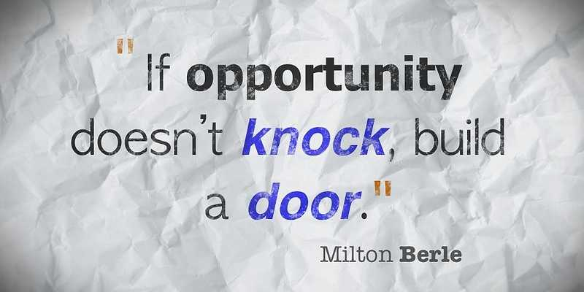

**Keys to Success!**

* Complete ALL assignments in a timely manner!
* Participate
* Take Notes
* Ask for help if you don’t understand something.
* Be creative!
* Do your own work!

