Marketing II

2018-2019 Northern York High School

Instructor: Mr. Kluck – Room 201

[kkluck@nycsd.k12.pa.us](mailto:kkluck@nycsd.k12.pa.us)

**Course Description**

Marketing II is a structured education program that integrates class studies with practical work application and a curriculum tied directly to a competitive nature. In addition, Marketing II may inspire students to study marketing at a more advanced level, which can lead to a challenging and lucrative career.  
This course presents students the opportunity to further understand the impact that marketing can have on individuals, as well as businesses and society. Students will be engage in market research activities and will work with area businesses in gathering information. The students will also transfer their marketing, merchandising, and entrepreneurial skills to the marketing of the school’s student store. The students will also study the impact that marketing has on the sports industry. Students enrolled in this course may also participate in DECA’s Competitive Events Program. Students can compete in a marketing category at the district, state, and national levels. In addition, the student can also participate as a Co-op student while enrolled in marketing. This of course is optional. This program dismisses students from school part of the day to receive on-the-job training in a field closely related to the field of marketing

**Textbooks**

*Marketing Essentials,* Farese, Kimbrell, and Woloszyk, Glencoe/McGraw Hill, © 2009.



**Course Schedule (Tentative):**

Week(s):

**1 – 3** **The Marketing Plan –** SWOT Analysis / Writing a Marketing Plan

**4 – 9**  **Selling –** Preparing the Sale, Initiating the Sale, Presenting the Product, Closing the Sale, Using Math in Sales (School Store)

**10 – 11** **The New Age of Marketing** – Social Media, Email, Online Promotional Plans, etc.

**12 – 15**  **Marketing Information Management** – Marketing Research, Conducting Marketing Research and Applying It

**16 – 19 Product and Service Management –** Product Planning, Branding, Packaging, and Labeling, Extended Product Features (Warraties, Guarantees, etc.)

**20 – 22 Risk Management**

**23 – 26**  **Developing a Business Plan / Financing a Business**

**27 – 32 Employability and Career Development –** Identify Career Opportunities in Marketing, Finding and Applying for a Job

* **Marketing II students will also be responsible for running the school store, organizing pep rallys, promoting DECA to Marketing I students, etc.**

**What is DECA?**

Membership in this organization will allow you opportunities to participate and to travel to the district, state and international level of competitions that have been scheduled for this school year. Your participation in this organization will also provide you the chance to be part of the many activities that your officer team will be planning.

**DECA Events:**

* Philadelphi Universtiy
* Philadelphia 76ers
* District Competion (TBA)
* State Competition @ The Hershey Lodges (TBA)
* Pittsburgh Pirates
* National Competion in Orlando, FL (April 27-30)

**How will you be graded?**

Students will be assessesd through **Chapter Quizzes, Unit Exams, Chapter Projects, Note Checks, and Other Content Related Projects / Assignments**

**Make Up Work** --- Absent work will be due the day following your return to school. Any notes or assignments that you miss due to an absence are your responsibility, if you have any questions please let me know. If you need to schedule time before or after school to make up work please let me know. Work that you miss due to an absence can be found in the “Absent” bin located in the front of the room. If you miss a test due to an absence it must be made up upon your return to class (either during class, during a study hall, or after school).

**Late Work:**

* ALL work should be completed by its assigned due date, however, I understand that things happen (you forget to do it, you leave it at home, etc.). I will accept late work, with a 10% deduction for each day it is late, after ten days it will become a zero permanently.

**Classroom Behavior**

* Don’t allow cell phones to be a distraction! NOTE: If you are working on a project and using your phone to listen to music; I CAN tell the difference between texting and changing a song!
* Come to class ready to participate.
* No food or drink at the computers (follow school guidelines).
* Be on time to class every day. Skipping or chronically coming to class late will not be tolerated.

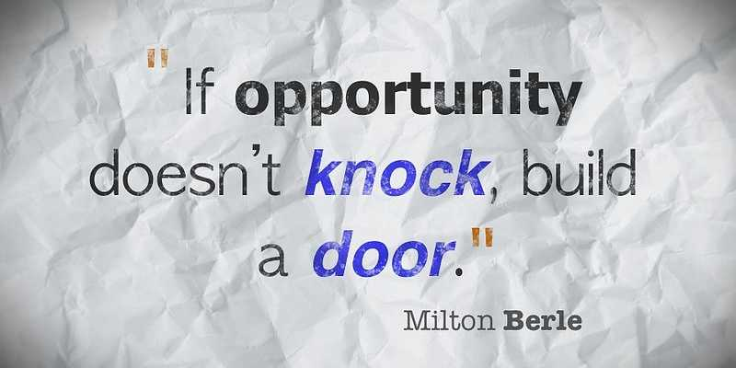

**Keys to Success!**

* Complete ALL assignments in a timely manner!
* Participate
* Take Notes
* Ask for help if you don’t understand something.
* Be creative!
* Do your own work!

