**(6) Topic: I Remember Date: 9/15/21**

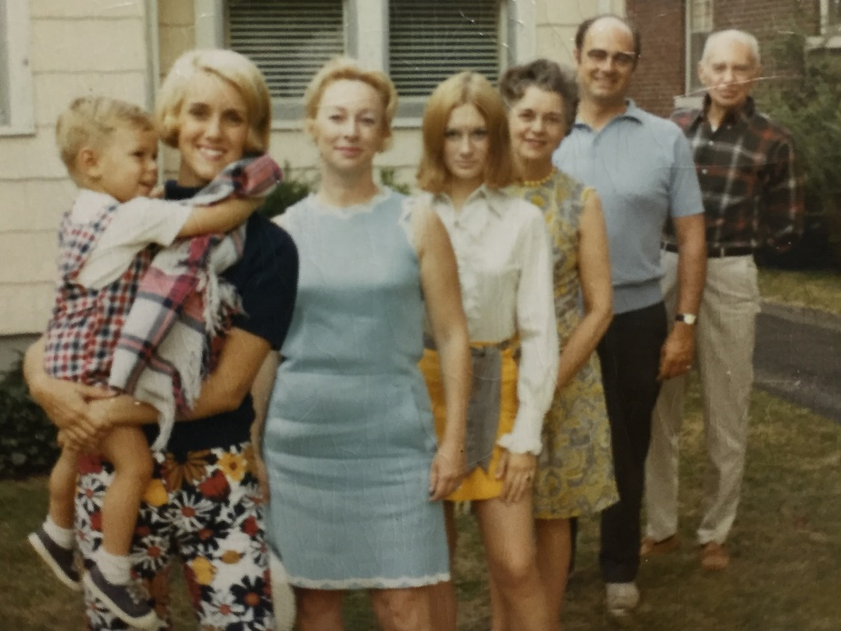Write a poem in which each line begins *I remember.* Write *eight* lines. Your lines do not need to be equal in length, and they do not need to rhyme. End each, however, with a period.

**I remember**

**I remember**

**I remember**

**I remember**

**I remember**

**I remember**

**I remember**

**I remember**

**TC: Find my grandfather in this photo.**