(**11**) Topic: **Thoreau Drummer** Date: **9/27/21**

**“If a man does not keep pace with his companions, perhaps it is because he hears a different drummer. Let him step to the music which he hears, however measured or far away.” --Henry David Thoreau (1817-1862)**

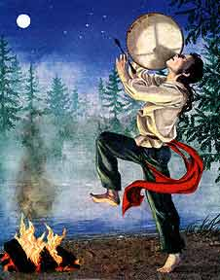

Explain at least one way in which you “hear a different drummer”—one way in which you are unique and individualistic in thought or action or preferences, despite pressures from friends or society.

**Suggested opening:**

One way in which I “hear a different drummer” is . . .

**TC: Play Philip Philips’ song “Gone”**

**and listen for the word “drum.”**

[**https://www.youtube.com/watch?v=oozQ4yV__Vw**](https://www.youtube.com/watch?v=oozQ4yV__Vw)