**Chapter 2 – Analyzing Transactions into Debit and Credit Parts**

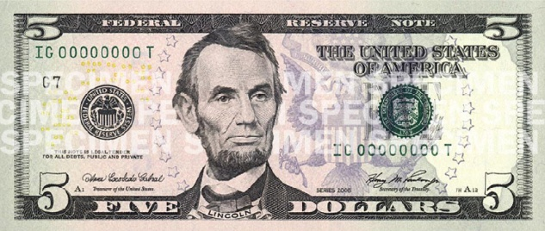***2-3 Analyzing How Transactions Affect Owner’s Equity*** (pages 43-49)

**Received Cash from Sales** (page 43) - Analyze Transaction **(PP Slide 2):** January 10. Received cash from sales, $1,100.00

**Which accounts are affected?**

**How is each account classified?**

**How is each classification changed?**

**How is each amount entered in the accounts?**

**Sold Services on Account** (page 44) - Analyze Transaction **(PP Slide 3):** January 12. Sold services on account to Main Street Services, $500.00

**Which accounts are affected?**

**How is each account classified?**

**How is each classification changed?**

**How is each amount entered in the accounts?**

**accounts receivable –**

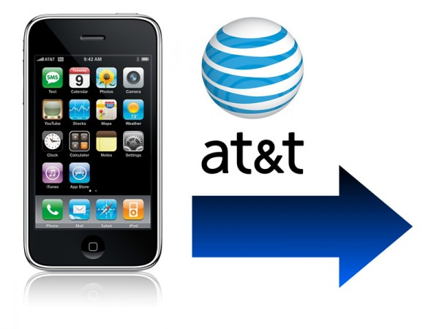**Paid Cash for an Expense** (page 45) – Analyze Transaction **(PP Slide 4):** January 12. Paid cash for communications bill for cell phone and internet services, $80.00

**Which accounts are affected?**

**How is each account classified?**

**How is each classification changed?**

**How is each amount entered in the accounts?**

* **In this particular transaction, we are not only tracking our cash account and owner’s equity; but also how much we are paying for communications expenses.**

**

**Received Cash on Account** (page 46) - Analyze Transaction **(PP Slide 5):** January 16. Received cash on account from Main Street Services, $200.00

**Which accounts are affected?**

**How is each account classified?** **How is each classification changed?**

**How is each amount entered in the accounts?**

**Paid Cash to Owner for Personal Use** (page 47) Analyze Transaction **(PP Slide 6):** January 16. Michael Delgado withdrew equity in the form of cash, $350.00

**Which accounts are affected?**

**How is each account classified?**

**How is each classification changed?**

**How is each amount entered in the accounts?**

* **In this particular transaction, we are not only tracking our cash account and owner’s equity; but also how much the owner is withdrawing from the business.**

**REVIEW:   
Audit Your Understanding** (page 49)

1. **Which two accounts are affected when a business pays cash for a cell phone bill?**
2. **Which two accounts are affected when a business sells services on account?**
3. **Which two accounts are affected when a business receives cash on account?**
4. **Is the drawing account increased on the debit side or credit side?**
5. **Are revenue accounts increased on the debit side or credit side?**

*Forensic Accounting* (page 48) – Pyramid Schemes **(10 points) ---** Excel Spreadsheet FA_CH02



* 1. Aplia Assignments:
  + Work Together (Practice --- as a class)
  + On Your Own
  + Application Problem **(20 points)** (GRADED)