Name: __________________________________ 7/8th Health Ed.

Section: _________________ Study Guide Packet

**Unit Essential Questions:** 1. How can nutritional and exercise choices affect human health?

2. How can a person make healthy nutritional choices?

## **“Nutrients” - substances in foods needed: 1. to grow 2. have energy 3. stay healthy** (**Read p. 104-107)**

|  |  |  |
| --- | --- | --- |
| **Nutrient** | **Purpose** | **Foods** |
| **Protein** |  | meat, fish, milk, beans, eggs |
| **Carbohydrates**  **1. Simple**  **2. Complex**  **3. Fiber** | 1. ______________________________________________  2. ______________________________________________  3. ______________________________________________ | 1. sugar, candy, fruit, honey  2. grains, pasta, starchy vegetables  (potatoes)  3. bran, whole grains, vegetables |
| **Fats**  **1. Saturated**  **2. Unsaturated**  **3. Trans fats** | 1. _______________________________________________  2. _______________________________________________  3. ___________________________ (in hydrogenated oils) | 1. whole milk, butter, fatty meat  2. fish, olive and corn oils  3. margarine, cookies, chips, etc. |
| **Water** |  | *need 8 glasses of water a day*  (NOT from soda, tea & sport drinks) |

Page 2

**\*\*What do vitamins and minerals do for us?**

|  |  |  |
| --- | --- | --- |
| **Vitamins** | **Purpose** | **Foods** |
| **Vitamin A** |  | Carrots, sweet potatoes,  leafy vegetables |
| **Vitamin C** |  | Oranges, tomatoes, strawberries |
| **Vitamin D** |  | Milk, fish, “sunshine” |

|  |  |  |
| --- | --- | --- |
| **Minerals** | **Purpose** | **Foods** |
| **Calcium** |  | Dairy foods |
| **Iron** |  | Beans, red meat, prunes |

** Guidelines for Good Nutrition** (p. 107-108)

**1. Eat a _________________________ of foods**

**2. Eat more _________, _____________________, ______________ & _________________ rich foods.**

**3. Eat less: ________________, ___________________ and _________________.**

**4. Balance food & ___________________________ ___________________________. Textbook p. 111-114 (warning…book shows old Pyramid )** Page 3

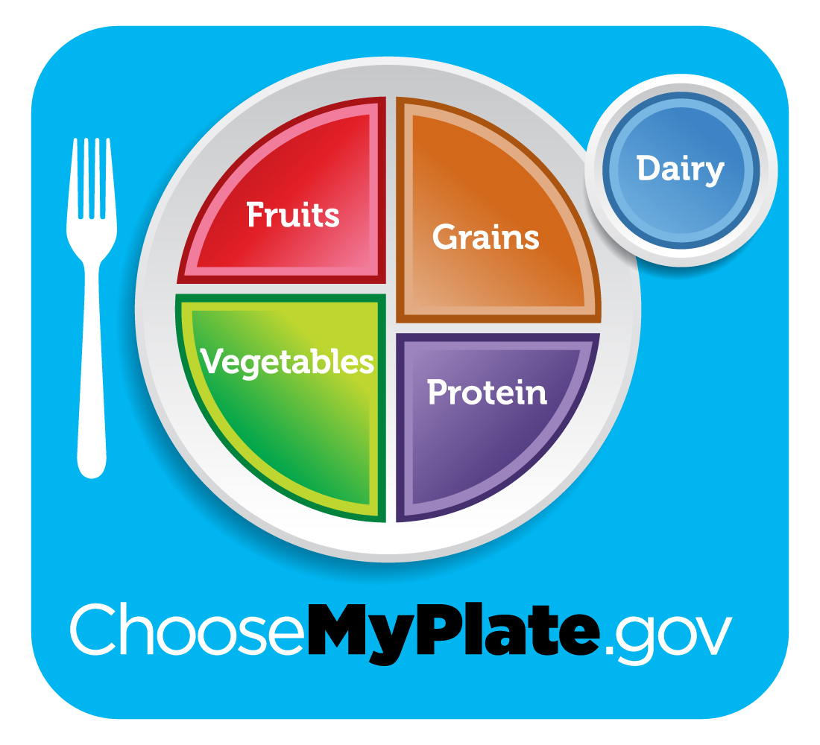

|  |  |  |  |  |
| --- | --- | --- | --- | --- |
| **GRAINS** | **VEGETABLES** | **FRUITS** | **MILK** | **PROTEIN** |
| make half your grains whole for fiber | eat a variety of different colored vegetables | canned, fresh or  fruit juice  eat a variety | choose low fat milk, yogurt or cheese | choose low-fat meats like chicken & fish.  beans, nuts & seeds can replace meat |

**Aim to include all food groups at each meal.**  **\*Limit fat, salt and sugar intakes.**

The amount needed varies from person to person.

**Calories needed daily depends on: __________, ____________, & _________________**

Page 4

Consumer Choices about Food (**Read pages 109-110)**

# **Health Consumer -** ____________________________________________________________________________

Beware! Ads promote many foods high in sugar, fat and salt.

Beware! Ads promote high calories through “super sizing” portions.

*_____________________ _________________________ - the amount of food the label nutrition information is based on

*_____________________________________________ - the percentage of daily nutrition provided by eating 1 serving

**What can you learn from a label?**

1. What is the serving size? ______________

2. How many calories / serving? ___________

3. How much of the fat is saturated? _________ grams

4. How much protein /serving? ______________ grams

5. What % of the daily value is there / serving?

a. fiber ____________

b. calcium ____________

Can you find nutritional information on a food label?

Use the picture on page #109 to answer the questions.

Healthful Eating Habits Page 5

Textbook p. 116-119

**Why make healthy food choices?**

1. __________________________________________ 2. _______________________________________

**What are some healthful eating habits?**

1. Follow the ________________________ _____________________ guidelines.

2. Pay attention to _________________________________ sizes.

Ways to remember how much is a portion:

3 oz. of meat = _______________________________________

1 tablespoon of peanut butter = ___________________________________

1 cup of fruit/ vegetables = ___________________________________

3. Eat a healthy breakfast every morning.

Breakfast should include:

a. _____________ ____________________________ ex.- _______________ _______________

b. __________________________________ ex. ________________ _______________

**(continue to next page)**

Healthful Eating Habits (cont.) Page 6

4. Buy/pack a healthy lunch.

Good lunch choices could include:

Grain - _________________________________ Calcium rich food - ______________________

Fruit/vegetable - ________________________________ Protein - ______________________

5. Choose snacks low in fat, sugar & salt… and high in nutrients.

Good snacks:

Food choices may reduce the risk of diseases:

**Cancer**

**Type II Diabetes**

**Osteoporosis**

**Heart Disease**

Page 7

Maintaining a Healthy Weight (p. 128-131)

Factors which may influence a person’s choices about food:

_______________________________________________________________________________________________

_____________________ _____________________ - the way you see your body

**____________________________________________ [BMI]** – a method for accessing body size based on height and weight

___________________________________ - a unit of heat that measures the energy in food and used in activity

**Calories and Weight** - p. 134 & 135

**Weight control is all a matter of balance**: Calories in (what you eat) VS Calories burned off (activity)

|  |  |  |
| --- | --- | --- |
| **Same Weight**  Calories in = Calories burned off | **Gain Weight**  ______________  _______________ **>** | **Lose Weight**  ____________  **<** ________________ |

**Calorie intake increases when**: **Calories burned off increase:**

1. _____________________________________________ 1. _________________________________________

2. ____________________________________________ 2. _________________________________________

Textbook p. 132 & 133 Page 8

**Eating Disorders** - are extreme eating behaviors that can lead to serious illness or death

**Help for Eating Disorders Includes:** 1. ___________________________________________

**Underweight Conditions**

**Overweight Condition**

Fear gaining weight and starve themselves-

(refuse to eat)

Repeatedly eat large amounts of food and then purges

– (vomiting or using laxatives)

Excessive level of body fat

*Binge eating – eating too much food at one time

*Binge eating – eating too much food at one time

2. ___________________________________________

3. ___________________________________________