Skimming at the DQ Grill and Chill

(Forensic Accounting)

The Gettysburg DQ Grill and Chill is a classic example of a family owned, small business. The shop’s floor plan is typical of businesses in this market. The ice cream machines are located just behind the counter with topping rails located to the left. Customers place their orders at the register, receive a number associated to their order, and then wait to the left of the registers or at a table for their number to be called. In most cases a single employee serves a customer from order to check out.

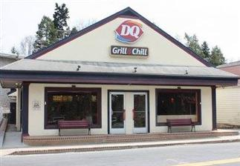A basic principle for preventing fraud is to segregate the duties of custody, authority, and reporting. No one employee should be responsible for two or more of these duties. At Dairy Queen the employees have access to the ice cream and toppings (custody) and sell these items to customers (authority).

Owner’s Kurt and Dana Kluck are well aware that this lack of segregation of duties places their business at risk. Employees are very familiar with the pricing of the store’s ice cream menu. Rather than using the cash register, employees could mentally calculate the total sales amount. The money taken from the customer could go in the employee’s pocket rather than the cash register. This type of fraud is known as *skimming*. Despite this risk, the Kluck’s believe that the one-on-one service provided by their employees enhances the friendly atmosphere that has made their shop a local landmark.

The Kluck’s contract a local janitorial service to clean the store each morning. Unknown to the employees, the janitorial service has also been instructed to measure the volume of product (ice cream and toppings). The daily difference in product volumes indicates how much product was actually sold. For example, selling ten small cones should use 60 ounces of ice cream mix and ten cones.

The Kluck’s have asked you, the Flawless Forensic Accounting Firm (FFAF), to perform an analysis to determine if any of their employees are skimming sales. They have provided you with data for the past four months. The data includes the quantity sales of each ice cream menu item, the names of the two employees working that day, and the actual product usage as determined by the janitorial service. As a result of product errors and breakage, a 3.0% difference between the actual and expected volume of product used is considered acceptable.

DIRECTIONS: Go to Mr. Kluck’s teach page and click on the Accounting I tab. Scroll to the bottom of the page and access the FA_DQ.xls (Spreadsheet) and FA_DQ.ppt (PowerPoint). Read through the PowerPoint and then open the spreadsheet. Save a copy of the spreadsheet on your desktop so you can edit and manipulate it. Next, click the instruction tab. Follow the instructions then provide the Kluck’s with answers to the following questions. Save and share your spreadsheet with Mr. Kluck when you are finished.

1. Does an analysis of ice cream usage provide any evidence to suggest that an employee is involved in a skimming fraud? Explain.
2. Does an analysis of toppings, sugar cones, and waffle cones support the evidence identified in your analysis of the ice cream usage? Explain.
3. Does the evidence prove that an employee is involved in a skimming fraud? Explain.
4. Write a brief (4-5 sentences) summary suggesting what actions the Kluck’s should take as a result of your analysis.
5. 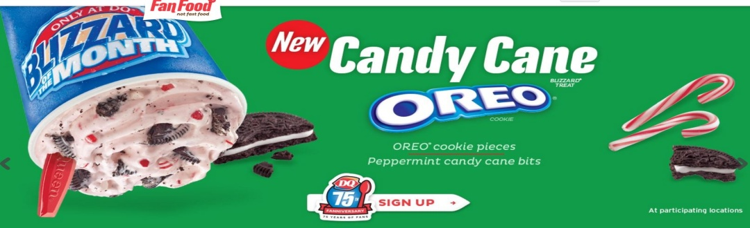Identify another situation when it would be beneficial for a business to utilize a *Forensic Accounting* team.