|  |  |  |
| --- | --- | --- |
|  |  | Welcome to Mrs. Hazen’s Social Studies Class |
| I would like to take this opportunity to introduce myself and express my excitement about the upcoming year. This is my third year teaching at Northern Middle School, and I am excited about the upcoming year.  I have been married for 23 years, and I have 3 boys. My family and I enjoy sports and being outdoors, especially walking our dog Pepper. Contact PHONE:  717-432-8691 ex1336  EMAIL:  dhazen@northernyork.org |  | Welcome to Western Civilization and to your 7th grade year at Northern Middle School! It is sure to be a fantastic year!  We will be studying the geography, culture, people, and impacts that Western Civilizations had throughout history. These include:   * The Fertile Crescent * Egyptians * Early Empires * The Greeks * The Romans * Germanic Peoples * The Middle Ages * Renaissance * The Elizabethan Age * Exploration  I will be using various resources throughout the year which will allow students to become familiar with both primary and secondary sources. I will utilize both independent and collaborative environments within the classroom to enhance students’ learning.Procedures ~Everyday students will complete a warm up upon entering the classroom.  ~All phones will remain turned off and inside your backpack or locker at all times.  ~Assignments will be posted in Schoology and in the classroom.  ~All work will be submitted through Schoology or turned in during class.  ~Students who have excused absences will need to make-up work. Students will be given the same number of days that they were excused to complete all missed work.  ~Students who are absent from class will need to check with me for what they missed and what will need to be completed.  ~All other late work will follow the school policy outlined in the student handbook.  ~Students are encouraged to talk with or email the teacher about assignments, grades, or with any other questions.  ~Students will remain in their assigned seat for the period  ~Students will wait to be dismissed by the teacher at the end of the period. No packing up early! Expectations |

~Be respectful of other’s time, resources, and space.

~Bring all materials to class, including your agenda.

~Sit in your assigned seat daily.

~Follow directions the first time they are given.

~Observe all rules in the student handbook.

~Students who are unable to adhere to the school rules and procedures will:

1. receive a verbal reminder;
2. 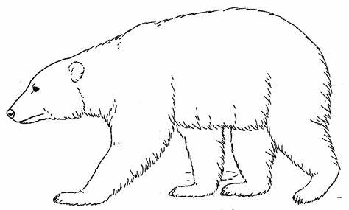have a conference with the teacher; and/or
3. receive an infraction or office referral.