**Chapter 2 – Analyzing Transactions into Debit and Credit Parts**

***2-2 Analyzing How Transactions Affect Accounts*** (pages 36-42)

***Opening Activity:*** Predict account titles and their classifications for a major league baseball or NFL team of your choice. Come up with as many as you possibly can. Be prepared to share with the class.  
  
  
Receiving Cash from Owner as an Investment (page 36) **(PP Slides 2-3)**

* + Each transaction changes the balances of ____________________accounts.
  + 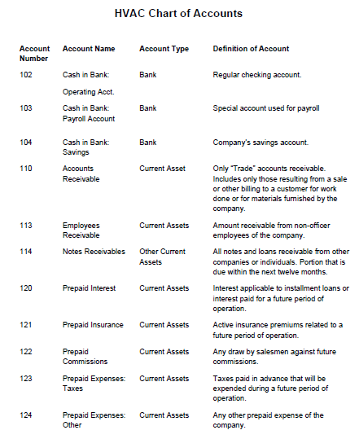You should use the same four questions every time a transaction is analyzed into its debit and credit parts…

**chart of account** –   
  
  
Analyze Transaction **(PP Slide 4):** January 2. Received cash from owner as an investment, $2,000.00

**Which accounts are affected?**

**How is each account classified?**

**How is each classification changed?**

**How is each amount entered in the accounts?**

Analyze Transaction **(PP Slide 5):** January 2. Paid Cash for Supplies, $165.00

**Which accounts are affected?**

**How is each account classified?**

**How is each classification changed?**

**How is each amount entered in the accounts?**

**\*\*\*FYI:** Don’t think of “debit” and “credit” as “good” or “bad”. Debit simply means left and credit simply means right.

Analyze Transaction **(PP Slide 6):** January 3. Paid cash for insurance, $900.00.

**Which accounts are affected?**

**How is each account classified?**

**How is each classification changed?**

**How is each amount entered in the accounts?**

Analyze Transaction **(PP Slide 7):** January 5. Bought supplies on account from Canyon Office Supplies, $220.00

**Which accounts are affected?**   
  
**How is each account classified?** **How is each classification changed?**  
  
**How is each amount entered in the accounts?**

**accounts payable –**

Analyze Transaction **(PP Slide 8):** January 9. Paid cash on account to Canyon Office Supplies, $100.00

**Which accounts are affected?** **How is each account classified?** **How is each classification changed?**

**How is each amount entered in the accounts?**

REVIEW: Audit Your Understanding (page 42)

1. **What are the four questions used to analyze a transaction?**

1. **What twp accounts are affected when a business buys supplies on account?**



* 1. Aplia Assignments:
  + Work Together (Practice --- as a class)
  + On Your Own
  + Application Problem **(20 points)** (GRADED)