**(5) Topic: Sight Date:** 9/14/21

Paint a picture with words. In a paragraph of eight lines, **describe one** of the following so that your readers will see what you are talking about.

***a fire a big fight***

***a snowfall a baseball game***

***a foggy morning a long bus ride***

***a dark cave a crowded classroom***

***an empty building a fancy motorcycle***

***a parade a flooded river***

***a lake a beautiful park***

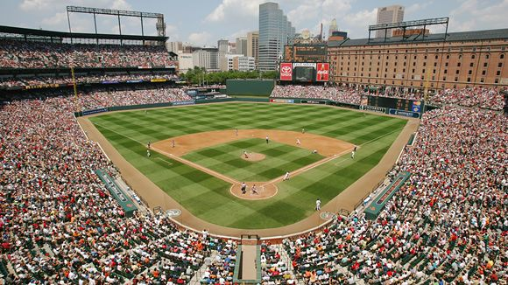

***a city street a sunset***

***a vacant lot the ocean***

**TC: Identify the location of this stadium.**