(**7**) Topic: **Signs of Fall** Date: **10/1/20**

What signs of fall have you noticed lately? Write a **numbered list of 16 or more signs** of fall.

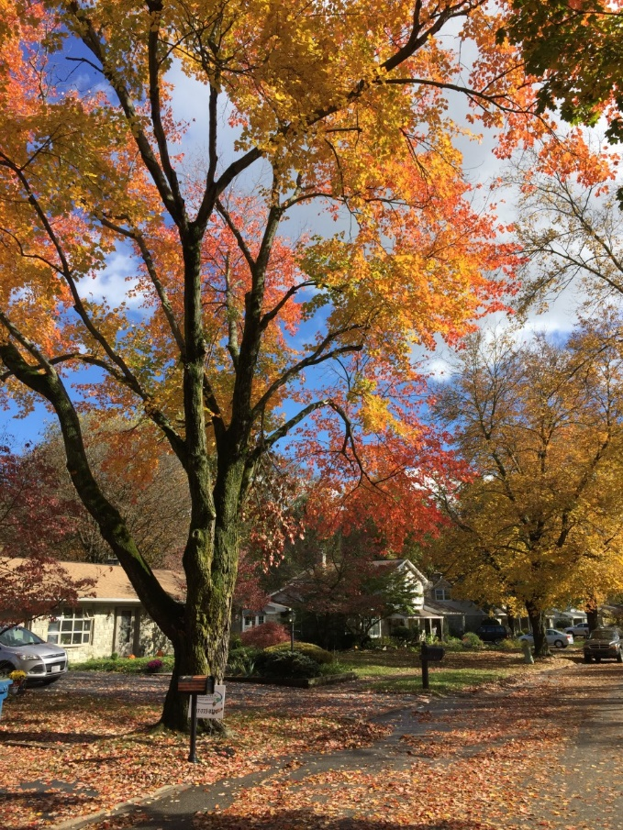

**1. leaves falling 9.**

**2. 10.**

**3. 11.**

**4. 12.**

**5. 13.**

**6. 14.**

**7. 15.**

**8. 16.**

***TC: What type of tree is this?***

***(a maple on Lamp Post Lane, Camp Hill)***

***TC: When was the first day of fall?***

***(September 23, 2019)***

