Name: ______________________________ 6th Grade Health

CS Section: _______________ Personal Health Unit

The Amazing Body

Webquest

C:\Documents and Settings\Staff.NMS-TEACH-RMXXX\Local Settings\Temporary Internet Files\Content.IE5\NKI0CPRA\MC900238192[1].wmf

1. **How the Body Works - Ears**

*Click on the hyper link ---- [**How the Body Works - Ear**](http://kidshealth.org/kid/htbw/htbw_main_page.html#cat116)**s**

*Click on the “**EAR picture”**

___ A. Click and watch the video

(use your speakers or headsets)

*Click on “**Article”**

___ B. Listen or read - Segments 1, 2, and 3

___ C. Go back to Segment #1 to label the ear diagram (**on the back**)

**Close the website and return to the WEBQUEST page.**

2. **Ourselves - Hearing**

*Click on the hyper link ----- [**Ears and Hearing**](http://www.topmarks.co.uk/Interactive.aspx?cat=69)

*Scroll down and click on “**Ears and Hearing**”

____ A. Click… **>I** to listen & do activities on Scenes 1,2, and 3

____ B. Practice labeling parts on Scene #4 – click & drag activity

____ C. Answer the review questions:

1. Changes vibrations into electrical messages. _______________________

2. Carries messages to the brain. _______________________

3. Begins vibrations when sound waves hit it. _______________________

4. The body part which understands messages. _______________________

Name: ________________________

Section: ____________

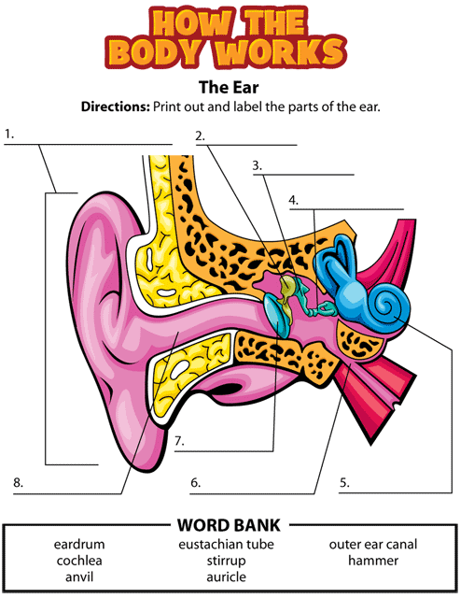

Webquest --- part 2

1. **How the Body Works- Eyes**

*Click on the hyper link ---- [**How the Body Works - Eyes**](http://kidshealth.org/kid/htbw/htbw_main_page.html#cat116)

*Click on the “**EYE picture”**

___ A. Click and watch the video

C:\Documents and Settings\Staff.NMS-TEACH-RMXXX\Local Settings\Temporary Internet Files\Content.IE5\MIPHQJV0\MC900281284[1].wmf

(use your speakers or headsets)

*Click on “**Article”**

___ B. Listen or read - Segments 1, 2, and 3

___ C. Go back to Segment #1 to label the eye diagram (**on the back**)

**Close the website and return to the WEBQUEST page.**

2. **Ourselves - Seeing**

*Click on the hyper link ----- [**Eyes and Seeing**](http://www.topmarks.co.uk/Interactive.aspx?cat=69)

*Scroll down and click on “**Your Senses, Eyes and Seeing**”

____ A. Click… **>I** to listen scenes 1, 2, and 3

____ B. Organize the sight steps on Scene #4 - click & drag activity

____ C. Practice labeling parts on Scene #5 – click & drag activity

____ D. Answer the review questions:

1. Focuses what you are looking at. ______________________

2. Protects the surface of the eye. ______________________

3. Sends messages from the eye to the brain. ______________________

4. Contains cells which detect light and color. ______________________

**GOOD JOB …. WEBQUEST IS COMPLETE !**

Name: __________________________

Section: ____________________

