**The 8 Step Personal Selling Process**

Personal selling is the most expensive form of advertising and to be effective one should use a step by step process to gain the most benefit. Personal selling can adjust the manner in which facts are communicated and can consider factors such as culture and behavior in the approach. They can ask questions to discover the specific need of the customer and can get feedback and adjust the presentation as it progresses.

**The Personal Selling Process** - **a consecutive series of activities conducted by the salesperson, that lead to a prospect taking the desired action of buying a product or service and finish with a follow-up contact to ensure purchase satisfaction**

**Step One** --- Prospecting - the first step in the personal selling process

* The process of looking for and checking leads is called **prospecting** or determining which firms or individuals could become customers.
* Up to **20%** of a firm's customer base can be lost for reasons such as **transfer**, **death**, **retirement**, **takeovers**, **dissatisfaction with the company**, and **competition**.
* A steadily growing list of qualified prospects is important for reaching the sales targets.

*Qualifying a prospect:*  A lead is a name on a list. It only becomes a prospect if it is determined that the person or company can benefit from the service or product offered.

* A qualified prospect has a **need**, **can benefit from the product**, and **has the authority to make the decision**.

**Step Two** --- The Pre-approach - **involves the collecting of as much relevant information as possible prior to the sales presentation.**

* The pre-approach investigation is carried out on new customers but also on regular customers.
* Systematic collection of information requires a decision about **applicability**, **usefulness**, and **how to organize the information for easy access and effective use**.

**Step Three** --- The Approach  
The salesperson should always focus on the **benefits** for the customer. This is done by using the product's features and advantages.

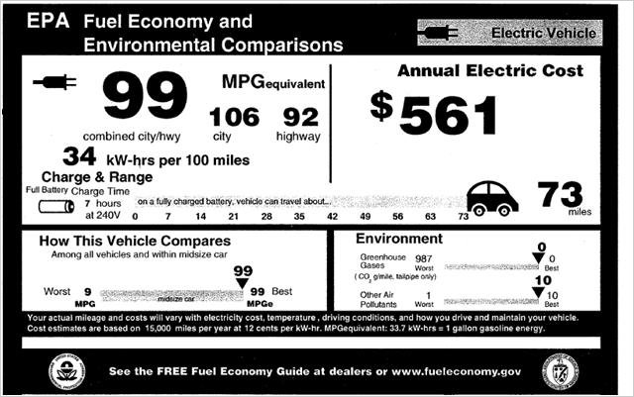  
This is known as the FAB technique (Features, Advantages and Benefits).

* Features: **Refers to the physical characteristics such as size, taste etc.**
* Advantages: **Refers to the performance provided by the physical characteristics.**
  + Example(s): it doesn’t stain, great gas mileage, etc.
* Benefits: **Refers to the benefits for the prospect**.
  + Example(s): Saves you 20% on replacement cost, earn rewards, etc.

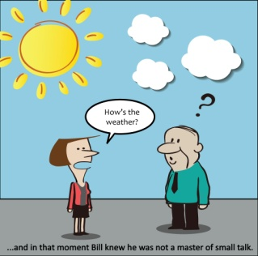**Step Four** --- The Sales Presentation - After the prospects interest has been grasped, the sales presentation is delivered. This involves a **"persuasive vocal and visual explanation of a business proposition"**.

* It should be done in a **relaxed atmosphere** to encourage the prospect to share information in order to establish requirements.
* Some **small talk** may be necessary to reduce tension but **the purpose always remains business**.

**Step Five** --- The Trial Close - part of the presentation and is an important step in the selling process.

* Known as a temperature question - **technique to establish the attitude of the prospect towards the presentation and the product.**

**  
Step Six** --- Handling Objections

* Objections are often indications of **interest** by the prospect and should not be **viewed with misgiving by salespeople**.
* The prospect is in fact requesting additional information to help him or her to **justify a decision to buy**.
* The prospect may not be **fully convinced and the issues raised are thus very important**.
* It also assists the salesperson to establish exactly what is on the prospect's mind.

**Step Seven** --- Closing the Sale - the last part of the presentation.

* Many salespeople fear the closing of a sale.
* Closing a sale is **only the confirmation of an understanding**.
* Fear will disappear if **the salesperson truly believes that the prospect will enjoy benefits after the purchase of the product**.

**Step** **Eight** --- The Follow-up – **the sale does not complete the selling process**

* Follow-up activities are very important and are useful **for the establishment of long-term business relationships**.
* It is important to check if **the products have been received in good condition**, **to ensure the customer is satisfied**, or **to see if they have any further questions about the product or other products you offer**.