(**3**) Topic: **A Delicious Dinner** Date: **9/7/21**

Your mother/father promised to prepare your favorite dinner tonight. In a paragraph of eight lines, describe it in detail, from beginning to dessert. Make it sound so *mouthwatering* that the whole class will want to come home with you this evening . . . with food-lover Mr. A. first in line! Possible Opening:

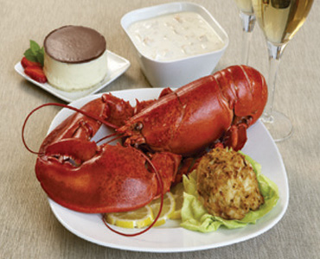

***Mom’s/Dad’s delicious dinner begins with . . .***

**TC: Identify food at upper right corner of this topic.**

**Name the five senses: sight, sound, taste, touch, smell.**