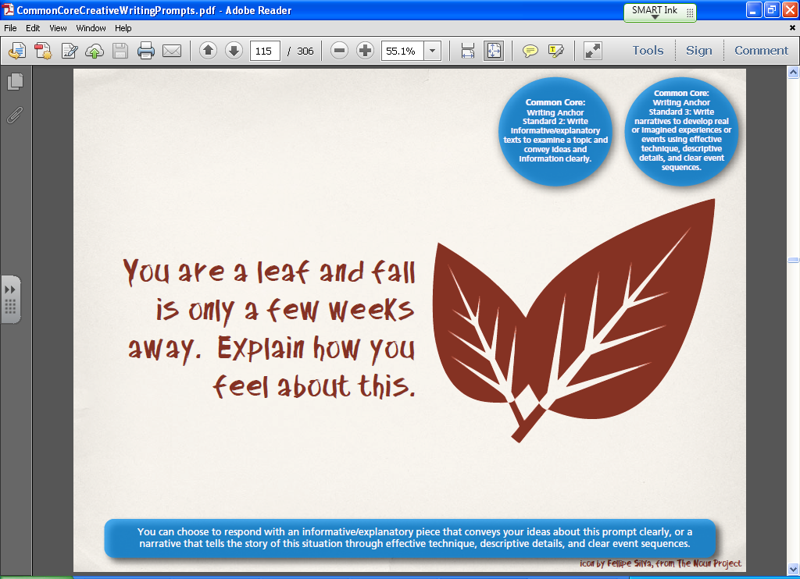(**4**) Topic: **Leaf** Date: **9/13/21**

Directions: Write a paragraph of eight lines in which you, as a leaf, describe your life **experiences** thus far in the year. Include your family, friends, and predicted outcome. How do you **feel** about the approaching fall?

Ask for literary device (personification), then play video as a warm-up:

<https://www.youtube.com/watch?v=1Mb6NxixRk8>

Play Jim Gaffigan “Seasons” video:

<https://www.youtube.com/watch?v=bjrI64S9DTw&t=324s>

Start @ 5:51.