***Chapter 5*** – Relationships within Triangles

In this chapter we address three Big IDEAS:

1. **Using properties of special segments in triangles**
2. **Using triangle inequalities to determine what triangles are possible**
3. **Extending methods for justifying and proving relationships**

|  |  |
| --- | --- |
| Section: | **5 – 1 Midsegment Theorem** |
| Essential Question | **What is a midsegment of a triangle?** |

Key Vocab:

|  |  |  |
| --- | --- | --- |
| Midsegment of a Triangle | A segment that connects the midpoints of two sides of the triangle.  **Example:** are *midsegments* |  |

Theorem:

|  |  |
| --- | --- |
| Midsegment Theorem | |
| The segment connecting the midpoints of two sides of a triangle is   1. parallel to the third side 2. and is half as long as that side. |  |

Show:

Ex 1: In the diagram of an A-frame house,  are midsegments of . Find .





Ex 2: In the diagram,. Explain why 



, so *S* and *W* are the midpoints of , and  is a midsegment of . Therefore,  by the *Midsegment Theorem*.

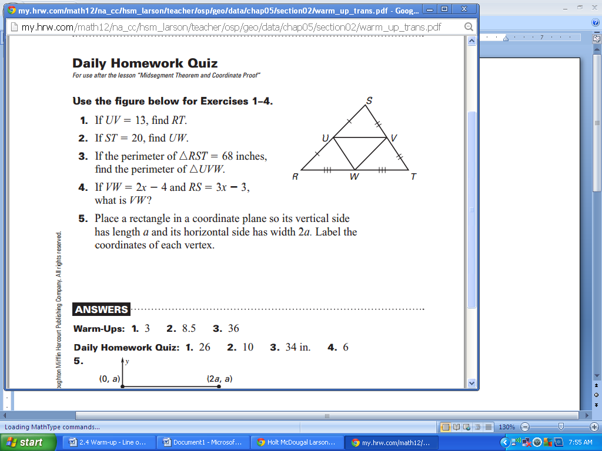

Try it:

Ex 3: Use  to answer each of the following

**a.** If If *UV* = 13, find *RT.*

*RT* = 26

**b.** If the perimeter of , find the perimeter of .

inches

**c.** If  and , what is *VW*?

 

|  |  |
| --- | --- |
| Section: | **5 – 2 Use Perpendicular Bisectors** |
| Essential Question | How do you find the point of concurrency of the perpendicular bisectors of the sides of triangle? |

Key Vocab:

|  |  |  |
| --- | --- | --- |
| Perpendicular  Bisector | A segment, ray, line, or plane, that is perpendicular to a segment at its midpoint. | Line *n* is *bisector* of |
| Equidistant | The same distance from one figure as from another figure. | Point *D* is *equidistant* from points *C* and *E* |
| Concurrent | Three or more lines, rays, or segments that intersect in the same point. | Lines *l, n,* and *m* are *concurrent lines*. Point *P* is their *point of concurrency.* |
| Point of Concurrency | The point of intersection of concurrent lines, rays, or segments |

|  |  |  |
| --- | --- | --- |
| Circumcenter | The point of concurrency of the three perpendicular bisectors of the triangle | Point *C* is the *circumcenter* |

Theorems:

|  |  |
| --- | --- |
| Perpendicular Bisector Theorem | |
| **In a plane, if**  a point is on the perpendicular bisector of a segment, | **then**  it is equidistant from the endpoints of the segment. |
| Point *C* is on the bisector of |  |
|  |  |

|  |  |
| --- | --- |
| Converse of the Perpendicular Bisector Theorem | |
| **In a plane, if**  a point is equidistant from the endpoints of a segment, | **then**  it is on the perpendicular bisector of the segment. |
|  | Point *C* is on the bisector of |
|  |  |

|  |  |
| --- | --- |
| Circumcenter Theorem | |
| The perpendicular bisectors of a triangle intersect at a point that is equidistant from the ***vertices*** of the triangles |  |

Show:

Ex 1: In the diagram,  is the perpendicular bisector of. Find *PR.*



 

Ex 2: In the diagram,  is the perpendicular bisector of.

a. Which lengths in the diagram are equal?



b. Is *L* on ?

Yes

Ex 3: In the diagram, the perpendicular bisectors of ΔABC meet at point G.

Find the value of, and, if and.

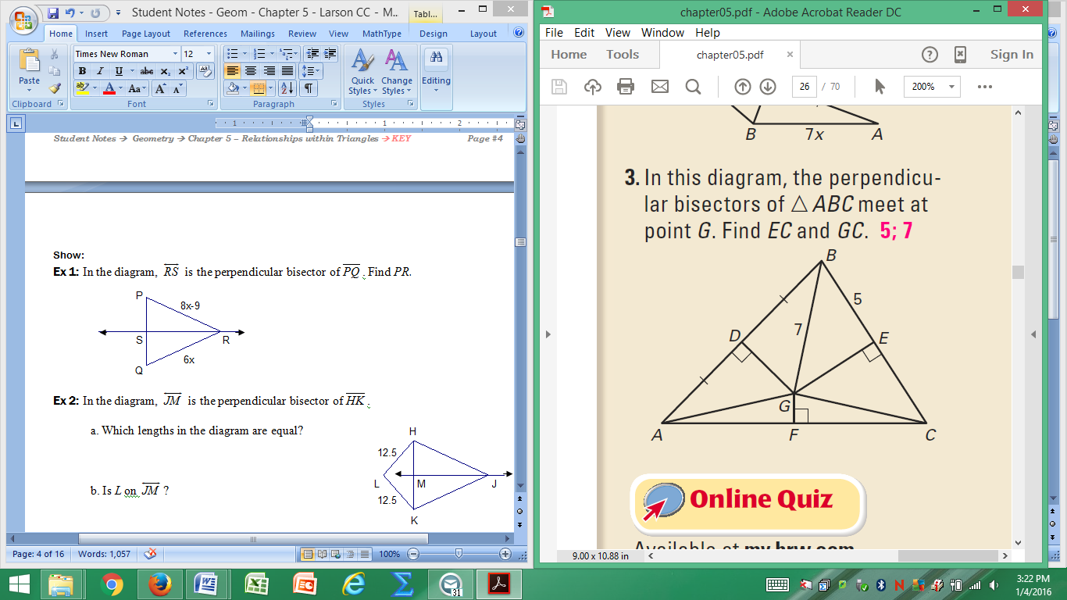





By the Circumcenter Theorem., The perpendicular bisectors of a triangle intersect at a point that is equidistant from the ***vertices*** of the triangles

|  |  |
| --- | --- |
| Section: | **5 – 3 Use Angle Bisectors of Triangles** |
| Essential Question | When can you conclude that a point is on the bisector of an angle? |

Key Vocab:

|  |  |  |
| --- | --- | --- |
| Incenter | The point of concurrency of the three angle bisectors of the triangle. | Point *I* is the *incenter.* |

Theorem:

|  |  |
| --- | --- |
| Angle Bisector Theorem | |
| **If**  a point is on the bisector of an angle, | **then**  it is equidistant from the two sides of the angle. |
|  |  |
|  |  |

|  |  |
| --- | --- |
| Converse of the Angle Bisector Theorem | |
| **If**  a point is in the interior of an angle and is equidistant from the sides of the angle, | **then**  it lies on the bisector of the angle. |
|  |  |
|  |  |

|  |  |
| --- | --- |
| Incenter Theorem | |
| The angle bisectors of a triangle intersect at a point that is equidistant from the ***sides*** of the triangle. |  |

Show:







|  |  |
| --- | --- |
| Ex 1: Find the measure of . | Ex 2: For what value of *x* does *P* lie on the bisector of ? |

|  |  |
| --- | --- |
| Ex 3: Find the value of . | Ex 4: Find the value of. |

Ex 5 In the diagram, *G* is the incenter of . Find *GW*.









|  |  |
| --- | --- |
| Section: | **5 – 4 Use Medians and Altitude** |
| Essential Question | How do you find the centroid of a triangle? |



Key Vocab:

|  |  |  |
| --- | --- | --- |
| Median of a Triangle | A segment from one vertex of the triangle to the midpoint of the opposite side | are *medians*. Point *C* is the *centroid*. |
| Centroid | The point of concurrency of the three medians of the triangle. |
| Altitude of Triangle | The perpendicular segment from one vertex of the triangle to the line that contains the opposite side. | are *altitudes*. Point *O* is the *orthocenter*. |
| Orthocenter | The point of concurrency of the three altitudes of a triangle. |

Theorems:

|  |  |
| --- | --- |
| Centroid Theorem | |
| The medians of a triangle intersect at a point that is two thirds of the distance from each vertex to the midpoint of the opposite side. |  |

Show:

Ex 1: In , *P* is the centroid

P

T

K

J

H

|  |
| --- |
| 1. If , find *PT* and *JT.*      1. If and |

Ex 2: Show that the orthocenter can be inside, on, or outside the triangle.

|  |  |  |
| --- | --- | --- |
| Inside = Acute Triangle | On = Right Triangle | Outside = Obtuse triangle |

Ex 3: Decide whether is a *perpendicular bisector, angle bisector, medians,* and/or *altitude.* Name **ALL** terms that apply.

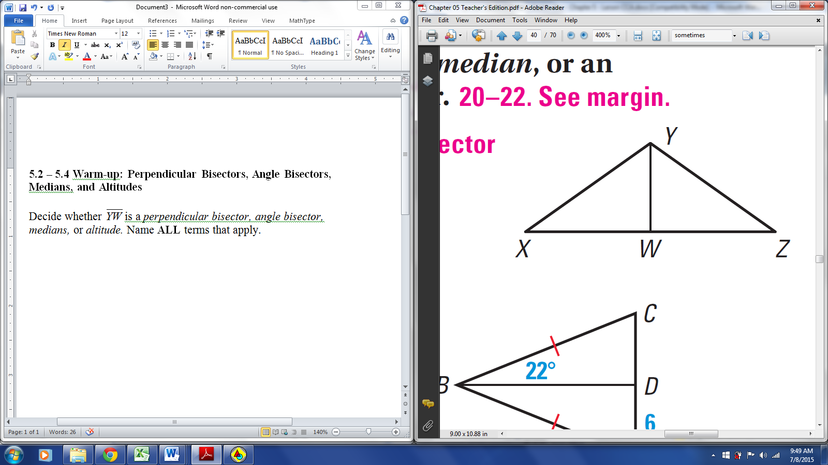

1.  Altitude
2.  angle bisector
3.  median
4. perpendicular bisector, angle bisector, medians, & altitude
5.  perpendicular bisector, angle bisector, medians, & altitude
6.  perpendicular bisector, angle bisector, medians, & altitude

Ex 4: Prove that if an angle bisector of a triangle is also an altitude, then the triangle is isosceles.

Given: bisects ;

 is an altitude of 

Prove:  is isosceles

|  |  |
| --- | --- |
| **Statements** | **Reasons** |
| 1. bisects | 1. Given |
|  | 1. Def of bis. |
|  | 1. Def. of altitude |
|  | 1. Perp. lines form  adj |
|  | 1. Reflexive |
|  | 1. ASA |
| 1. is isosceles | 1. Def. of Isos. |

Closure:

* Name the four points of concurrency of a triangle and describe how each is formed.

1. Circumcenter-intersection of the perpendicular bisectors
2. Incenter-intersection of the angle bisectors
3. Centroid-intersection of the medians
4. Orthocenter-intersection of the altitudes

|  |  |  |  |  |
| --- | --- | --- | --- | --- |
| Section: | | **5 – 5 Use Inequalities in a Triangle** | | |
| Essential Question | | How do you find the possible lengths of the third side of a triangle if you know the lengths of two sides? | | |
| Side Opposite | |  | is *opposite*  is *opposite*  is *opposite* |

Theorems:

|  |  |
| --- | --- |
|  | |
| **If**  one side of a triangle is longer than another side, | **then**  the angle opposite the longer side is larger than the angle opposite the shorter side. |
|  |  |
| **If**  one angle of a triangle is larger than another angle, | **then**  the side opposite the larger angle is longer than the smaller angle. |
|  |  |

|  |  |
| --- | --- |
| Triangle Inequality Theorem | |
| The sum of the lengths of any two sides of a triangle is greater than the length of the third side. |  |

Show:

Ex 1: Draw an obtuse scalene triangle. Find and label the largest angle and the longest side. Find and label the smallest angle and shortest side. What do you notice?

The longest side and the largest angle are opposite each other. The shortest side and smallest angle are opposite each other.

Ex 2: List the sides AND angles in order from smallest to largest.

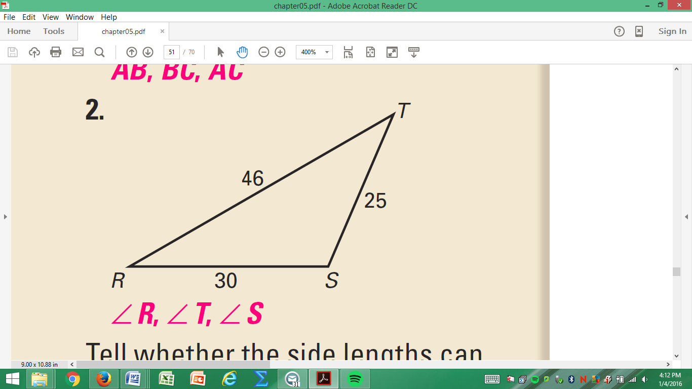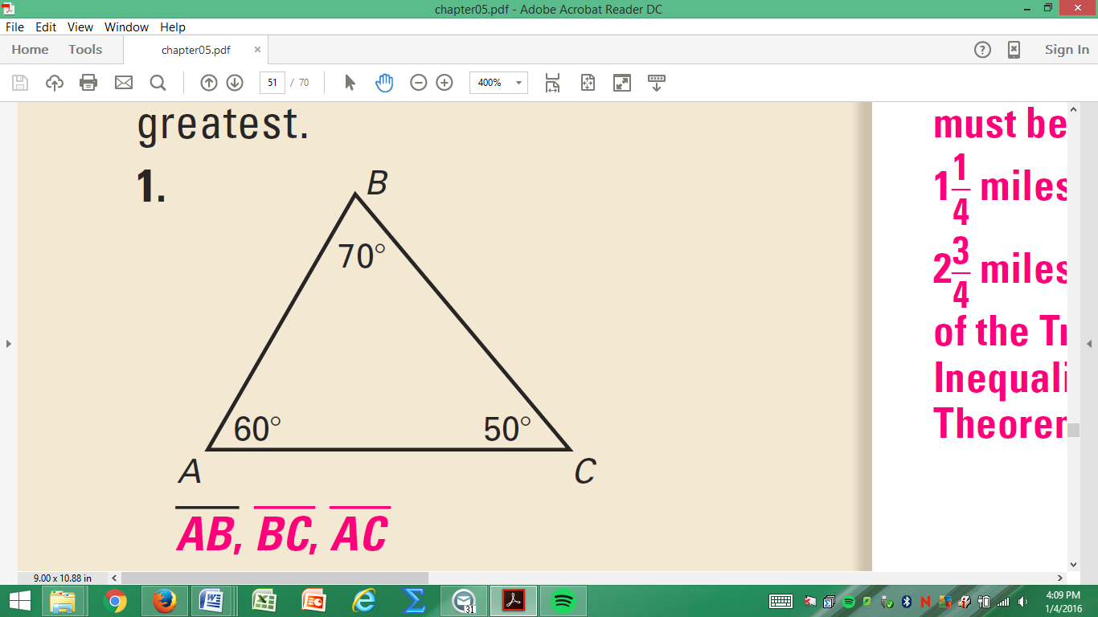

|  |  |
| --- | --- |
|  |  |

Ex 3: Three wooden beams will be nailed together to form a brace for a wall. The bottom edge of the brace is about 8 feet, and the sides are about 12 feet and 14 feet. One of the angles measures about 86° and the other measures about 35°. What is the angle measure opposite the largest side of the brace?

|  |  |
| --- | --- |
| A. | C. |
| B. | D. |

Ex 4: A triangle has one side of length 11 and another of length 6. Describe the possible lengths of the third side.

 Greater than 5 and less than 17

Can the third side have a length of 21?

No

Can the third side have a length of 5.5?

# Yes

Ex 5: Is it possible to construct a triangle with the given lengths? Explain.

|  |  |  |
| --- | --- | --- |
| 1. 9, 11, 18     Yes | 1. 2, 4, 6     No | 1. 3, 6, 11     No |

|  |  |
| --- | --- |
| Section: | **5 – 6 Inequalities in Two Triangles and Indirect Proof** |
| Essential Question | How do you write an indirect proof? |

Theorems:

|  |  |
| --- | --- |
|  | |
| Hinge Theorem (SAS Inequality Theorem) | |
| **If**  two sides of one triangle are congruent to two sides of another triangle, and the included angle of the first is larger than the included angle of the second, | **then**  the third side of the first is longer than the third side of the second. |
|  |  |

|  |  |
| --- | --- |
| Converse of the Hinge Theorem (SSS Inequality Theorem) | |
| **If**  two sides of one triangle are congruent to two sides of another triangle, and the third side of the first is longer than the third side of the second | **then**  the included angle of the first is larger than the included angle of the second. |
|  |  |

Show:

Ex 1: Given that  , how does compare to ?



 by the

SSS Inequality (Hinge Converse)

Theorem

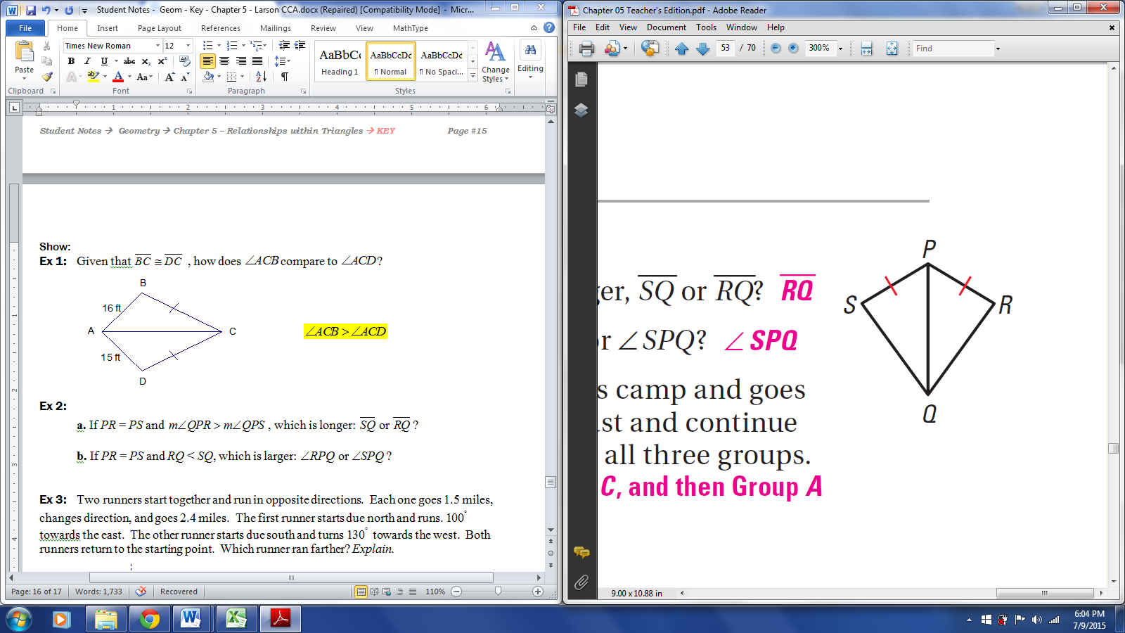Ex 2:

**a.** If *PR* = *PS* and , which is longer: ?

 by the SAS Inequality (Hinge) Theorem

**b.** If *PR* = *PS* and *RQ* < *SQ*, which is larger: ?

 by the SSS Inequality (Hinge Converse) Theorem

Ex 3: Two runners start together and run in opposite directions. Each one goes 1.5 miles, changes direction, and goes 2.4 miles. The first runner starts due north and runs.  towards the east. The other runner starts due south and turns  towards the west. Both runners return to the starting point. Which runner ran farther? *Explain.*



Each triangle has side lengths 1.5 mi and 2.4 mi, and the angles between those sides are . The *Hinge Theorem*, the third side of the triangle for Runner 1 is longer, so Runner 1 ran further.

Key Vocab:

|  |  |
| --- | --- |
| Indirect Proof | A proof in which you prove that a statement is true by first assuming that its opposite is true. If this assumption leads to an impossibility or contradiction, then you have proved that the original statement is true. |

Key Concept:

How to Write an Indirect Proof:

1. Identify the statement you want to prove. Assume temporarily that this statement is false by assuming that its opposite is true.

2. Reason logically until you reach a contradiction

3. Point out that the desired conclusion must be true because the contradiction proves the temporary assumption false.

Ex 4: Write an indirect proof.





Ex 5: Write an indirect proof.

Given: 

Prove: 



Closure:

* Describe the difference between the Hinge Theorem and its Converse.

The Hinge Theorem is also called the SAS Inequality Theorem and it makes a conclusion about the third side of a triangle.

The Converse of the Hinge Theorem is also called the SSS Inequality Theorem and it makes a conclusion about the included angle of a triangle.