*People with interstitial cystitis may also have a defect*

*in the protective lining (epithelium) of the bladder.*

*A leak in the epithelium may allow toxic substances*

*in urine to irritate your bladder wall.*

[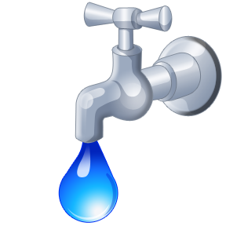](http://www.trin.com/wp-content/uploads/2013/03/leaky-faucet-four21.png)

**Symptoms:**

* Chronic pelvic pain
* Persistent urge to urinate
* Small amounts of urine
* Bladder sensitivity

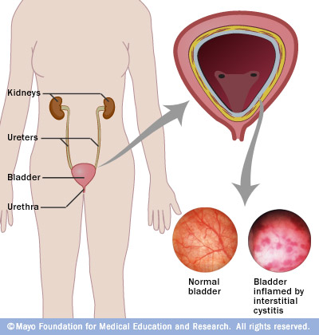

**Preventions/ Ways to reduce the risk:**

Common triggers, such as menstruation, sitting for a long time, stress, exercise and sexual activity.

* **Dietary changes.** Common bladder irritants — carbonated beverages, caffeine in all forms , citrus products. Also avoid similar foods, such as tomatoes, pickled foods, alcohol spices, and sweeteners.
* **Bladder training.** Bladder training involves timed urination — going to the toilet according to the clock rather than waiting for the need to go.
* **Wear loose clothing.**
* **Reduce stress.**
* **If you smoke, stop.**
* **Exercise.**

[](http://www.google.com/url?q=http://tiaschroederfitness.com/did-someone-say-tomato-pill/&sa=U&ei=LS88VOflDrSJsQTVk4HwBg&ved=0CCYQ9QEwCA&usg=AFQjCNHZB1o5egpeVedVmJbNZGRdkRzGuA)

The exact cause of Interstitial Cystitis is uknown. The disease is more likely to affect women over the age of 30 who suffer from a chronic pain disorder. However, unproven suggestions have linked it to be due to hereditary, autoimmune disease, infections, or an allergy.

[](http://www.google.com/url?q=http://www.clker.com/clipart-orange-meditating-silohette.html&sa=U&ei=oi88VMrdCLeUsQS4p4GgBw&ved=0CDAQ9QEwDQ&usg=AFQjCNGMppzCQGmo7pbxcuMSKcudFr8NNQ)

[www.mayoclinic.org/diseasesconditions/interstitial-cystitis](http://www.mayoclinic.org/diseasesconditions/interstitial-cystitis)