Name:_________________________________________ Date:_____________

Section: (Grade,Period)______________

Scalene Triangle 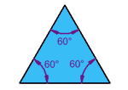 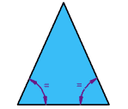

*Scalene Triangle Equilateral Triangle Isosceles Triangle*

1) *Identify* and **circle** YOUR sketched “Health Triangle.”

A. It's a scalene triangle because all the lengths of the sides are different.

B. It is an isosceles triangle because the lengths of two sides are the same.

C. It’s an equilateral triangle because all three sides are the same length.

2) What is the perimeter of your triangle in inches?