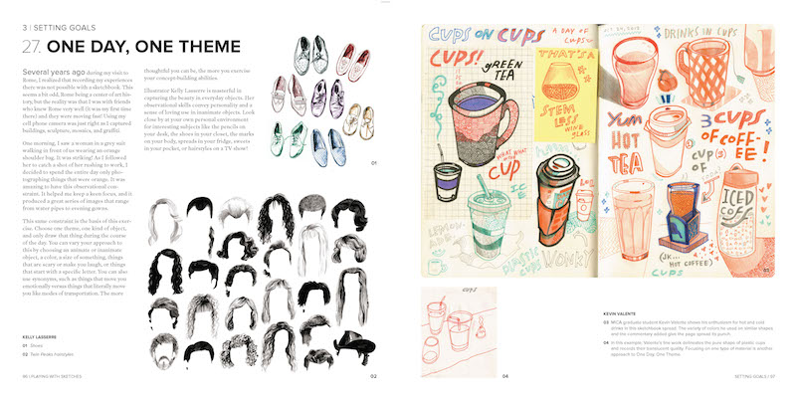For each of the next 5 days, pick a theme for the day – hair styles, shoes, cups, - and fill a page with drawings focused on that theme. How many variations can you come up with?

Share your pages through Schoology, email, or one drive. Consider posting the drawings to our classroom twitter (@nhsAPart #NYCSDart) or Instagram (@northernhsart #NYCSDart). I can’t wait to see what you create 😊