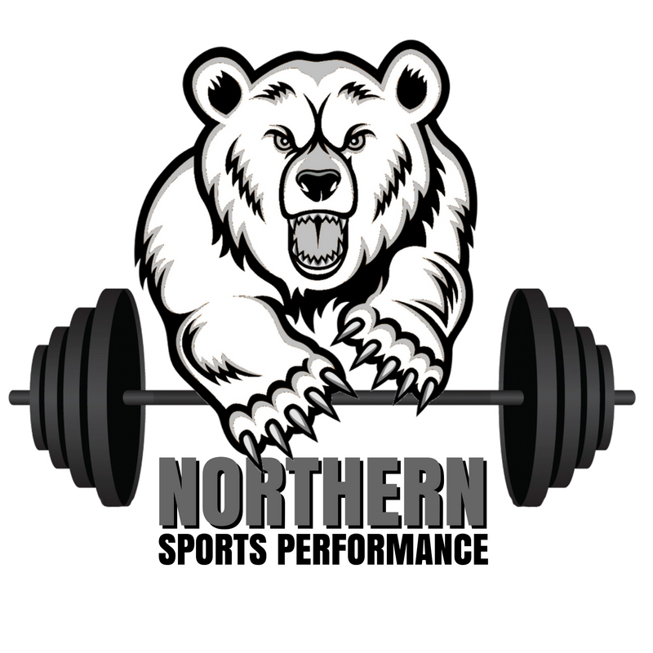

**NORTHERN YORK**

**SPORTS PERFORMANCE**

**RECOVERY AND NUTRITION PACKET**

**Dom Salomone CSCS**

**Email: Dsalomone34@gmail.com**

This packet highlights tips for effective recovery from training and competition as well as explains each of the 5 nutrition goals. Follow these guidelines to stay energized during training/practice/games, enhance recovery between workouts, and maintain a healthy body composition so we can be as successful as possible!

**“If teenage athletes want to take a big step forward in development, it would be wise to make an effort to “out-sleep” and “out-eat” their peers. These two things are powerful magnifiers of everything they do in skill development and strength and conditioning.”**

**-Eric Cressey, Cressey Sports Performance**

Be disciplined in all aspects of training. There are 168 hours in a week. You spend a 5-10 hours in the weight room and on the field training with sport and strength coaches. What you do with the other 158-163 hours really makes the difference between good athletes and **GREAT** athletes.

Please don’t hesitate to contact me with any individualized questions or for additional information on anything covered in this manual or regarding sports performance, injury rehabilitation, the recruiting process or playing at the collegiate level.

Manual created by Dominic Salomone CSCS, Northern High School Strength and Conditioning Coach.

Significant contributions by Matt Guise PTA, CSCS, USAW

**RECOVERY**

**Sleep! (8-10 hours)**

• Lack of quality (uninterrupted) sleep negatively effects athletic performance, decreases reaction time and decreases concentration.

**Tips to improve sleep quality**

• Get on a schedule, get to bed early

• Exercise

• Avoid caffeine in the evenings

• Keep bedroom dark and cool

• Put screens away before bed

**Manage stress and fatigue**

• Stressors come multiple factors: physiological (training, competitions), nutritional (food quality, hydration), social (hobbies, friends, family) and psychological (education, work).

• Be sure to take a full inventory of stress you are placing on your body and modify training and schedule accordingly.

• Avoid excessive training load during times of high sport demand like in-season/post-season.

• Incorporate recovery sessions on days without competition or performance training.

**To avoid excessive muscle soreness, include a combination of the following into your recovery day sessions:**

• Dynamic/static stretching, foam rolling, cryotherapy (ice bath, ice massage), light strength training, light aerobic activity (walking, jogging, bike riding)

**Supplementation such as Creatine should be discussed with your strength coach on an individualized basis.**

**5 Nutrition Habits of Champions**

1). Hydrate

2). Refuel

3). Eat at Regular Intervals

4). Choose a Varied and Balanced Diet

5). Meet Your Energy Needs

**Nutrition Daily Checklist**

_______ I ate breakfast

_______ I ate 3 balanced meals

_______ I ate 2-3 nutritious snacks

_______ I ate 2-3 pieces of fruit

_______ I ate 3-5 servings of vegetables

_______ I ate 3-4 servings of low-fat dairy products

_______ I ate a lean source of protein in each meal

_______ I ate a source of carbs in meals and snacks

_______ I selected foods moderate or low in fat

_______ I drank water regularly throughout the day

_______ I drank Powerade/Gatorade during intense conditioning

_______ I refueled within 30-60 minutes following training/practice/game

**5 Nutrition Habits of Champions**

(NOTE: 1 cup = 8oz of fluid)

**1) HYDRATE**

**Dehydration**

• Raises your body temperature

• Makes you work harder at lower exercise intensities

• Causes headache, dizziness, and fatigue

• Leads to muscle cramping

**Stay Hydrated**

• Drink at least 1 cup of water every hour

***TIP****: Carry a water bottle around with you for a reminder*

• Drink 1-2 cups of Powerade about 15 minutes before exercise

• Drink 1-2 cups of fluid every half hour during exercise

***TIP****: Select Powerade/Gatorade over water if you are a salty sweater or exercising for longer than an hour*

• Drink 3 cups of Powerade after exercise

***TIP***: *Add 2 more cups of water or Powerade for each pound lost during exercise*

**Monitor Hydration**

Urine color - Clear to pale yellow color and frequent need to urinate signal adequate hydration. Infrequent, dark urine reflects your body begging you to drink.

Weight loss - Weighing yourself before and after practice allows you to estimate

fluids lost in sweat. Replace each pound with 2 cups of fluid.

**5 Nutrition Habits of Champions**

(NOTE: 1 cup = 8oz of fluid

**2) REFUEL**

**Purpose**

1). To replace carbohydrates used for energy and build stores for the next workout

2). To provide protein for aid in muscle repair and to prevent muscle breakdown

3). To take the first step in recovery for your next workout

**Timing**

The critical time to refuel is within the first ***30 minutes*** after exercise, when your body is able to maximize absorption of carbohydrates and protein.

**Nutrients**

*Water*: at least 3 cups of fluid plus an additional 2 cups for each pound of weight loss

*Carbohydrates*: 50-100 grams

*Protein*: 15-25 grams

**5 Nutrition Habits of Champions**

(NOTE: 1 cup = 8oz of fluid

**3) EAT AT REGULAR INTERVALS**

**Purpose**

1). To maintain blood sugar levels for constant energy throughout the day

2). To minimize overwhelming hunger that leads to overeating late at night

3). To encourage protein synthesis instead of fat storage

**Recommendations**

Aim for 3-4 balanced meals daily

• Begin your day with a meal, even if it is not a traditional breakfast

• Regardless of your work or class schedule, make sure to include a lunch

*This may require packing food ahead of time*

• Prepare or purchase a dinner that is about the same size as breakfast and lunch

• For weight gain, eating a fourth meal will help you to consume more calories

• Starving all day and binging at night will sabotage both weight loss and weight

gain efforts

Aim for 2-4 snacks daily

• Including a small snack in between meals will control your hunger

• Adding large snacks will help increase calories needed for weight gain

• Eating a high-carbohydrate snack pre-workout will provide quick energy

• Refueling after exercise is an essential snack for all athletes

**5 Nutrition Habits of Champions**

(NOTE: 1 cup = 8oz of fluid

**4) CHOOSE A VARIED AND BALANCED DIET**

Follow these three steps to ensure you reach nutrient recommendations.

***Step 1: Eat antioxidant-rich fruits and vegetables***

**Goals**

1). Aim for 2-3 pieces of fruit per day

2). Aim for 3-5 servings of vegetables per day

*1 serving is 1 cup raw or 1/2 cup cooked veggies*

**Examples**

• Fresh fruit, frozen fruit, canned fruit in water or juice, 100% fruit juice, dried fruit

• Fresh vegetables, frozen vegetables, canned vegetables, 100% vegetable juice

***Step 2: Eat energy-supplying carbohydrates***

**Goals**

1). At least half of your calories should come from carbohydrates

2). Include a source of carbohydrates in every meal and snack

**Examples**

• whole grain bread, cereal, pasta, rice, oats

• starchy vegetables such as potatoes, sweet potatoes, winter squash, corn

• limit empty calories such as soda, sweet tea, candy, and sugary desserts

***Step 3: Eat muscle-building, lean protein sources***

**Goals**

1). Up to 1/4 of your calories may come from protein

2). Include a source of lean protein in every meal

**Examples**

• chicken breast, sirloin steak, lean ground beef, fish, egg whites, beans• low-fat dairy products such as skim milk, low-fat yogurt, and 2% cheese

**5 Nutrition Habits of Champions**

(NOTE: 1 cup = 8oz of fluid

**5) MEET YOUR ENERGY NEEDS**

**Match your food intake to your body composition goals.**

**Goal**

Our goal is to maintain a weight that will allow you to perform at your best and provide the recovery adaptations needed to fuel your performance. Severe increases or decreases in weight will prevent you from meeting this goal and negatively impact your performance during the season.

Below are sample plates with meals and various proportions on them. Use this as a guide to help assist you in your nutrition choices depending on the difficulty of the day. Remember, nutrition and recovery are just as important as training! Remember, the effort you put into your recovery will determine your level of success every day!

*Amended from Florida State University Nutrition

**Breakfast is the Meal that Makes Champions**

* One in four teenagers skip breakfast. Skipping breakfast, or any meal as an athlete, can have a dramatic effect on athletic performance. High school athletes should be encouraged to think of food as fuel for their bodies. Fueling their body well at the beginning of the day will ensure they have enough energy to meet the demands of practice sessions.
* Breakfast doesn’t have to be a full sit down meal. It can consist of a variety of snacks that are easy to eat on the go.
* Try to eat something between within the first 2 hours of waking up.
* Eat a mid morning snack to avoid over eating at lunch
* A 600-calorie breakfast is more effective for weight maintenance and loss then a 300-calorie breakfast. Adding 300-calories of chocolate cake to an existing 300-calorie breakfast lead to an increase in weightloss compared to those only eating the 300-calorie breakfast. (Jakubowicz et. al. 2012).
* Protein is key! At least 20 grams at breakfast. Skim milk, cheese sticks, and greek yogurt are great ways to add protein in the morning. Protein and fiber help to keep you full and avoid over eating later in the day.
* Cereal is great! You need carbs for energy and to help your muscles recover from the previous days training. Healthy cereals are also typically high in fiber and fortified with iron, which increased your bloods ability to use oxygen effectively and increases work capacity.
* Try to eat 20 grams for protein every 3-4 hours. This allows for proper absorption.
* The bottom line: any breakfast is better than no breakfast. A bigger breakfast is preferable to a skimpy one, but you have to eat something!

**The Athlete’s Plates are tools for you to better adjust your eating to the physical demands of your sport!**

EASY An easy day may contain just an easy workout or practice without the need to load up for competition with energy and nutrients. Easy day meals may also apply to if you are trying to lose weight or if you are in sports requiring less energy (calories) due to the nature of your sport.

MODERATE A moderate day may be one where you train twice but focus on technical skill in one workout and on endurance in the other. The moderate day should be your baseline from where you adjust your plate down (easy) or up (hard/race). Most meals will be this plate.

HARD A hard day contains at least 2 workouts that are relatively hard or competition. If your competition requires extra fuel from carbohydrates, use this plate to load up a day or two before, throughout, and after the event day.

The Athlete’s Plates are a collaboration between the United States Olympic Committee Sport Dietitians and the University of Colorado (UCCS) Sport Nutrition Graduate Program. For Educational Use Only.

