Chapter 1 – Importance of Entrepreneurship

***1.1 Entrepre-What?***

**Business** –

**Employee** –

**Entrepreneur** –

**Entrepreneurial** –

**Product** –

**Service** –

**Risk** –

* An entrepreneur risks **__________________**, **_______________**, and **________________** in the hope of getting greater rewards or benefits.

**Reward** –

* Can include **___________________**, **____________________**, or **________________________**.



Read ***Big Business versus Small Business*** (Textbook, pg. 6) --- *Why do you think so many business close? Do you know someone who owns a “small business”? Is there a “big business” that is in competition with them?*

***1.2 To Be or Not To Be an Entrepreneur: The Risks and Rewards***

**Rewards of Being an Entrepreneur**



**Risk of Being an Entrepreneur**



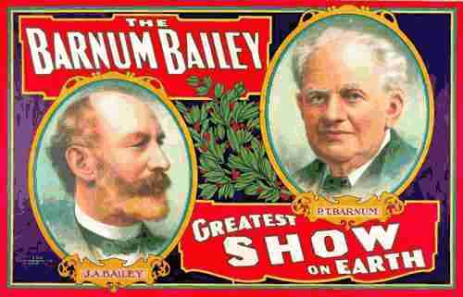***1.3 Entrepreneurship Through the Years*** (Students should come up with at least two of their own for each category.)

**1800’s**



**Early 1900’s**

**Mid-to-Late 1900s**

**Today’s Entrepreneurs**

**Serial Entrepreneurship** –

* Serial Entrepreneurs report that they are not driven by the desire for money so much as the impulse to innovate and to challenge themselves.